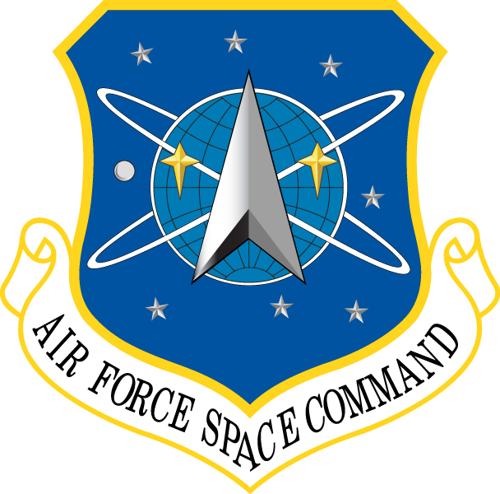

Prompt Global Strike (PGS)

Analysis of Alternatives (AoA)
Study Plan

Draft

28 Oct 2005
Table of Contents

1 introduction 6
1.1 Background 6
1.1.1 Guidance 6
1.2 Purpose 8
1.3 Scope 8
1.3.1 Required Capability/Mission Need 10
1.3.2 Capability Gap 10
1.3.3 Definitions 10
1.3.4 Ground Rules and Assumptions 11
1.3.5 Constraints 11
2 organizational responsibility 13
2.1 Working-level Integrated Product Team 13
2.2 Working Groups 13
2.3 Review Process 14
2.4 Overview of AoA Approach 15
2.5 Schedule 16
3 Threats & Scenarios 17
3.1 Introduction 17
3.1.1 Scenarios 17
3.1.2 Targets 18
3.1.3 Threats 18
3.1.4 Strategic Security Environments 19
3.2 Methodology 21
3.2.1 Scenario Selection Process 21
3.2.1.1 Stressor Matrix 21
3.2.1.2 Case 1: No Warning 22
3.2.1.3 Case 2: Unambiguous Warning 23
3.2.1.4 Defense Challenges 24
3.2.2 Scenario Recommendations 25
3.3 Target and Threat Development 25
3.4 Deliverables 25
4 Technology & Alternatives 27
4.1 Introduction 27
4.1.1 Studies 27
4.2 Methodology 27
4.2.1 Concept Selection 29
4.2.2 Alternative Development 30
4.2.2.1 Baseline Alternative 31
4.3 Description of Alternatives 31
4.4 Deliverables 32
5 Operations Concepts 33
5.1 Introduction 33
5.2 Methodology 33
5.2.1 Operational Views Development 33
5.2.2 Baseline Alternative Development 34
5.2.3 Operating Concepts Development 35
5.3 Operations Concepts Documentation 36
5.4 Deliverables 36
6 Measures of Effectiveness 37
6.1 Introduction 37
6.2 Methodology 37
6.2.1 Capabilities 37
6.2.2 Effects to Achieve 38
6.2.3 Measures of Effectiveness (MOE) 38
6.2.3.1 CAP 1 Global Reach. 38
6.2.3.2 CAP 2 Prompt Execution. 38
6.2.3.3 CAP 3 Multi-theater execution (robustness). 39
6.2.3.4 CAP 4 Survivability and reliability (weapon and delivery system). 39
6.2.3.5 CAP 5 High priority target defeat. 39
6.2.3.6 CAP 6 Interoperability (linkage to C4ISR, etc). 41
6.2.3.7 CAP 7 Precision Effects (minimize collateral damage). 41
6.2.4 Measures of Performance 42
6.3 Deliverables 42
7 effectiveness ANALYSIS 43
7.1 Introduction 43
7.2 Methodology 43
7.3 Detailed Effectiveness Analytical Plan 44
7.4 Models and Data 45
7.5 Accreditation of Models and Data 47
7.6 Other Supporting Analysis 48
7.7 Deliverables 48
8 Cost Analysis 49
8.1 Introduction 49
8.2 Cost Ground Rules & Assumptions 49
8.2.1 Ground Rules 49
8.2.2 Assumptions 50
8.3 Cost Methodology 50
8.3.1 Planning 50
8.3.2 Cost Analysis Approach 51
8.4 Cost Models and Data Collection 53
8.4.1 Cost Models 54
8.4.2 Cost Data Collection 55
8.4.2.1 Data Sources 55
8.4.2.2 Subject Matter Experts 56
8.5 Life Cycle Cost Analysis 56
8.5.1 Research and Development Cost 57
8.5.2 Investment Cost 57
8.5.3 Operations and Support Costs 57
8.5.4 Disposal Cost 58
8.5.5 Total LCC 58
8.5.6 Cost Sensitivity and Risk Analysis 60
8.6 Sufficiency Review 60
8.7 Deliverables 60
9 cost-effectiveness 62
9.1 Introduction 62
9.2 Methodology and Presentation 62
9.3 Risk Evaluation 63
9.4 Decision Criteria 63
9.5 Deliverables 63
10 report format 64
11 schedule 66
12 team members 67
13 Cost Model descriptions 69
13.1 Automated Cost Estimating Integrated Tools (ACEIT) 69
13.2 System Evaluation & Estimation of Resources – Software Estimation and Hardware estimation Model (SEER-SEM) & (SEER-H) 69
13.3 PRICE Estimating Suite 69
13.4 Unmanned Spacecraft Cost Model (USCM) 69
13.5 Constructive Cost Model II (COCOMO II) 69
13.6 NASA/Air Force Cost Model (NAFCOM) 70
13.7 Multi-Aircraft Cost Data and Retrieval (MACDAR) 70
13.8 Custom Spreadsheet Cost Model 70
14 acronyms 72
15 REFERENCES 74

List of Figures

Figure 2-1. PGS AoA Organization 13
Figure 2-2. Overall AoA Approach 16
Figure 3-1. Threat and Scenario Development 22
Figure 3-2. Threat and Scenario Development 23
Figure 4-1. Concept and Alternative Development 29
Figure 5-1. Operating Concept Development 33
Figure 5-2. Overarching PGS Operational View 34
Figure 7-1. Effectiveness Analysis Process 43
Figure 7-2. Modeling and Simulation Hierarchy 46
Figure 8-1. CAWG Activities Flow 52
Figure 9-1. Cost-effectiveness Dilemma 62
Figure 11-1. PGS AoA Schedule 66

List of Tables

Table 3-1. PGS Stressor Weighting Definitions 22
Table 3-2. Targets Grading Against Scenarios (Notional) 22
Table 3-3. PGS Stressor Matrix (Notional) 23
Table 3-4. MCO Scenario Grading Against Driving Factors (Notional) 24
Table 3-5. Defense Challenges Graded Against Scenarios (Notional) 24
Table 8-1. Cost Responsibility Matrix 51
Table 8-2. Development/Production WBS 53
Table 8-3. Potential Cost Models/Tools and Data Summary 54
Table 8-4. Appropriation Level Cost Reporting Format (BY$) 58
Table 8-5. Appropriation Level Cost Reporting Format (BY06$ and TY$) 58

introduction

This plan describes a recommended set of activities to be performed as part of a United States Air Force (USAF) and Department of Defense (DoD) effort on the Prompt Global Strike (PGS) Analysis of Alternatives (AoA). It provides an overview of the AoA process, describes the analysis approach, and lays out the responsibilities of the various Working Groups (WG) comprising the AoA study team. It also defines the schedule to implement the plan.

Section 1 explains the documented need and requirements which support performing the AoA and defines the scope and purpose. It also provides the study definitions, assumptions, and constraints to guide the study team.

Background

The Strategic Planning Guidance Fiscal Years 2006-2011 (SPG), March 2004 provides guidance for developing the desired capabilities and attributes needed to contend effectively with persistent and emerging challenges while extending relevant military advantages into the future. Specifically the SPG calls for implementing new concepts for global engagement, transforming the joint force, advanced strike capabilities and options for global strike. One of the four defense objectives in the SPG is to secure strategic access and retain global freedom of action. Two desired capabilities from the SPG are 1) Projecting and sustaining forces in distant anti-access environments and 2) Denying enemies sanctuary. The Defense Planning Guidance (DPG), Update Fiscal Years 2004-2009, May 2002, established the importance of long-range precision strike and the evolution of systems to overcome anti-access technologies and tactics. The DPG directs the development of capabilities to respond anywhere on the globe; deploy quickly, across great distances to supplement forward-stationed and deploying United States (US) forces; and project power even when the United States has no permanent military presence or only limited infrastructure in the region.

Guidance

The need for a prompt global strike capability is also supported by:

- National Security Strategy, 2002 – called for transformation through “developing assets such as… long-range precision strike capabilities, and transformed maneuver and expeditionary forces.”
- National Defense Strategy, 2005 – identified four persistent and emerging challenges: Traditional, states employing legacy and advanced military capabilities and recognizable military forces; Irregular, unconventional methods adopted and employed by non-state and state actors; Catastrophic, destabilizing capabilities outside “rational” control, surreptitious acquisition, possession, and possible terrorist or rogue employment of weapons of mass destruction (WMD); Disruptive, competitors developing, possessing, and employing “breakthrough” capabilities and tactics, techniques, and procedures that suddenly undermine US superiority.
- 2001 Quadrennial Defense Review (QDR) and 2002 Nuclear Posture Review (NPR) – laid out a new approach to deterrence requiring non-nuclear forces that can strike with precision at fixed and mobile targets throughout the depth of an adversary’s territory.
- Joint Vision 2020 – states a goal of full spectrum dominance, achieved by dominant maneuver and precision engagement.

The Joint Requirements Oversight Council (JROC) approved the PGS Mission Need Statement (MNS) and designated Air Force as the lead service. AFSPC is deriving an Initial Capability Document (ICD) from the Mission Need Statement to comply with the Joint Capabilities Integration and Development System (JCIDS). The draft ICD is in the review process at this time.

As documented in the draft Prompt Global Strike ICD, PGS supports the following joint guidance:

- The Force Application Functional Concept, February 2004 states “National security guidance has set a benchmark that our forces must be able to respond rapidly anywhere around the globe, to include within the US, and provide overwhelming force to meet any contingency.”
- The Strategic Deterrent Joint Operating Concept (JOC) expands on the guidance above: “Global Strike normally will be conducted with an abbreviated logistics footprint and have limited objectives and rapid execution timelines (minutes to hours). Because adversaries will continue to pursue anti-access strategies, Global Strike must allow for independent operations anywhere in the world with minimal, if any, support from overseas forces and facilities.”
- The Major Combat Operations JOC addresses the challenges of conducting large-scale military actions in a distributed, collaborative environment against a militarily capable regional nation state. Such nation states may have significant anti-access capabilities and weapons of mass destruction. The objective is not merely to destroy the adversary militarily, but to continuously shape the battlespace to effectively impact every dimension.
- Homeland Security JOC. To meet the challenges associated with securing the Homeland, DoD must plan for and be able to simultaneously defend the Homeland, provide support to civil authorities as directed, and help prepare for emergencies. Homeland Security operations ensure the integrity and security of the Homeland by detecting, deterring, preventing, and defeating external threats as early as possible and as far away from US borders as possible.
- Global Strike Joint Integrating Concept (ver. 1) reinforces the emphasis in the JOCs identified above: “…a Global Strike operation will normally be executed within compressed timelines (from seconds to days) while exerting persistent effects at potentially great distances from the continental United States and forward bases. These operations will include attacks against fleeting, ‘time-sensitive targets’. Global Strike operations must be executable without requiring establishment of a large logistical footprint.” PGS provides minutes to hours capability in support of the Global Strike JIC

PGS also supports the Joint Force Component Commander for Space and Global Strike CONOPS: “Gain and maintain both global and theater space superiority and deliver tailored, integrated, full-spectrum space support to the theater commander, while maintaining a robust defensive global counter-space posture. Lead day-to-day planning and integration efforts, and deliver joint global strike effects through deliberate, adaptive, and crisis planning, force integration, and robust command and control (C2) to support global deterrence, theater and national objectives. These capabilities are presented to the CDR USSTRATCOM or to other combatant commanders in support of national and theater objectives.”

In addition, Prompt Global Strike supports the Global Strike, Global Persistent Attack, Nuclear Response, and Homeland Security CONOPS as enabled by Space and C4ISR, and Global Mobility CONOPS. The following are examples of PGS relationships to AF CONOPS:

- Global Strike. PGS provides a rapid response capability in a range of global strike scenarios.
- Global Persistent Attack. PGS provides a capability to engage emerging, high-payoff, anti-access, and fleeting target sets during the combat operations phase of the conflict.
- Nuclear Response. PGS provides US decision makers a flexible strike capability with effects short of nuclear destruction.
- Homeland Security. PGS proactively neutralizes threats and responds to hostile attacks against the homeland.

Purpose

The purpose of the PGS AoA is to provide USAF and DoD decision-makers with the effectiveness and cost information necessary for convening a PGS milestone A decision and to justify the rationale for formal initiation of an acquisition program. The AoA assists the DoD in recommending alternatives that can meet PGS capability needs.

Scope

For the purposes of the AoA, Prompt Global Strike needs to be viewed in the context of two cases: case 1 – “no warning” and case 2 – “unambiguous warning.” The definitions of these cases are as follows:
- No Warning: National security demands an immediate response.
- Unambiguous Warning: Unambiguous warning occurs when the President decides, based on intelligence received, that a hostile entity has decided to initiate hostilities.
  - Strategic and/or tactical indicators are present
  - Planning and generation time allows the positioning of forces
Per direction of Office of Secretary of Defense/Program, Analysis and Evaluation (OSD/PA&E), the PGS AoA will examine these cases separately. The no warning case is covered first; the unambiguous warning case follows. The content of this Study Plan is primarily focused on case 1. Each of the WGs will re-examine the processes for case 1 for applicability to case 2 and modify them to appropriately apply their methodologies to case 2. Changes to the approach for case 2 will be reviewed with OSD prior to the case 2 analysis of alternatives.

The PGS AoA evaluates a range of system concepts to deliver precision weapons with global reach, in minutes to hours. The AoA considers end-to-end system concepts including such aspects as operations, maintenance, logistics, basing mode and the implications of other support requirements (e.g., C4ISR) for an integrated system. The alternatives which are evaluated in the AoA may be a single-system concept or families of systems, including two or more system concepts. The evaluation focuses on cost effectiveness and efficiency in employment of the PGS capabilities. Effectiveness is evaluated through the use of Measures of Effectiveness (MOE) and associated Measures of Performance (MOP). Determination of concept cost considers the full spectrum of life cycle costing, including development, investment, operations and support (O&S), and disposal/decommissioning.

Although the PGS ICD identifies both kinetic and non-kinetic alternatives, the AFSPC led PGS AoA focuses on kinetic strike options. Meaningful analytical comparisons between kinetic and non-kinetic concepts are very difficult. Other analysis efforts may address non-kinetic alternatives separately. In that circumstance, an opportunity to leverage the PGS AoA results would exist. Also, the utility of current Directed Energy technology is limited as a PGS capability; therefore, DE concepts are not included as an alternative in the PGS AoA. This approach is coordinated with OSD/PA&E.

Listed below are examples of concept types described in the PGS ICD. The final set of alternatives, resulting from the alternative development process described in Section 4.2, may be a combination of the concepts described below, or may include concepts not mentioned in the ICD.

- Baseline. The baseline force in the AoA is the President’s Budget FY 06-11. The analysis team references the QDR, DPG, and the Joint Strategic Capabilities Plan to provide insight on determining forces available in scenarios and the doctrine of deployed forces.
- High Speed Strike Systems. This approach requires development/adaptation of a piloted, remotely controlled, or autonomous subsonic/supersonic/hypersonic vehicle (aircraft, sea craft, or missile) to deliver precision standoff or direct attack subsonic/ supersonic/ hypersonic munitions.
- Operationally Responsive Space. An expendable and/or reusable launch vehicle that can deliver precision guided munitions.
- Military Space Plane. A reusable launch vehicle that could directly deliver precision guided munitions.
- Ground or Sea-based Expendable Launch Vehicle. This approach consists of either modification of current space launch vehicles, conversion of deactivated intercontinental ballistic missiles or sea-launched ballistic missiles, or building a new launch vehicle to deliver weapon payloads; such as small launch vehicle or submarine launched intermediate range ballistic missiles. An advanced reentry vehicle/body; such as, a common aero vehicle could be developed to accompany these missile systems.
- Air-Launched Global Strike System. This concept consists of an aircraft that air-launches Pegasus-like space launch vehicles configured with weapons and/or an aircraft delivering supersonic or hypersonic long-range cruise missiles.

Required Capability/Mission Need

The PGS Initial Capability Document (ICD) requires the capabilities to strike globally, precisely, and rapidly, with kinetic and non-kinetic effects, against high-payoff, time-sensitive targets in a single or multi-theater environment, regardless of forward presence or anti-access threats. Such capabilities allow the United States to capitalize on advanced standoff capabilities to achieve desired weapon effects while minimizing effects from anti-access strategies. Additionally, PGS gives the President, the Secretary of Defense, and combatant commanders the capability to rapidly strike targets (e.g., command and control nodes; integrated air defenses; and chemical, biological, radiological, and nuclear [CBRN] production/storage/launch facilities) in a time frame that is reduced from days/weeks to minutes/hours regardless of whether there is limited or no warning at all.

Once deployable forces are in place and engaged, a PGS capability can augment them to provide additional, low risk, stand-off support to warfighting Combatant Commanders (COCOM). Additionally, a PGS-based system can quickly engage and contribute to halting new aggression should another adversary choose to initiate hostilities elsewhere.

Capability Gap

The PGS capabilities are based on current technologies that respond to capability gaps and shortfalls documented in the PGS ICD. The PGS capabilities are directly linked to USSTRATCOM’s conventional strike capability gap. The USTRATCOM Integrated Priorities List, AF and Joint studies (listed in Section 4.1.1) and directives reflected in the JROC-approved PGS MNS identify necessary capabilities. In addition, PGS is also linked to the October 2004 the Air Force Integrated Capabilities Review and Risk Assessment (reference the PGS ICD).

Definitions

The following definitions are starting points for the Study Plan. The AoA study team may develop more specific definitions, including numerical thresholds and objectives for promptness and global reach, as the analysis process moves forward.

- Prompt. The PGS AoA will use the definition of prompt as described in the classified PGS ICD.
- Global. Global is defined as the capability to strike ay target set in the world.
- Strike. Strike is defined as the action taken to deliver the desired kinetic effects on a selected target or targets.
- Concept. In this study, a concept is an end-to-end operational system representation (e.g., Hypersonic Cruise Vehicle, its launch platform, payload, and supporting infrastructure).
- Alternative. Alternatives are concepts refined and synthesized into a limited number of alternatives (a single concept or a combination of concepts) that fit within the defined PGS operational architecture.

Ground Rules and Assumptions

The following list of ground rules and assumptions applies to the entire Study Plan. Specific ground rules and assumptions which apply exclusively or primarily to the cost analysis working group activities are listed separately in Section 8.

- Anti-access challenges are assumed to include both military limitations (active and passive defenses) and political limitations (access to controlled airspace, forward basing).
- The US continues to require strike capabilities even when US forces have little or no forward presence.
- Multi-theater execution requirements are an important attribute based on the National Defense Strategy (March 05):
  - Defend the US homeland
  - Operate in and from four forward regions
  - Swiftly defeat adversaries in overlapping campaigns and achieve decisive, enduring results in a single operation
  - Conduct a limited number of lesser contingencies.
- DoD prefers PGS solutions that limit collateral damage.
- The timeline for a PGS capability, for analysis purposes, begins at target identification and ends at effects on target. This includes mission planning, generation, flight time, etc.
- The effectiveness analysis concentrates on high-payoff, time-sensitive targets.
- PGS alternatives are meant to achieve their desired effects the first time in accordance with the mission plan. Those effects for this study are limited to kinetic effects.
- PGS alternatives operate under appropriate rules of engagement per scenario as determined by the Operations Concepts Working Group.
- The baseline blue forces (e.g. ISR, C4) available, including national assets, are considered in each scenario.

Constraints

The following list of constraints applies to the entire Study Plan:

- Logistics Support. Support of the prompt global strike capability is structured to satisfy system readiness and sustainability objectives using DoD logistics support infrastructure. To achieve this objective, the study team and the eventual system designers evaluate available commercial off-the-shelf technologies, common technologies with other weapon systems, and agile logistics concepts that use information technology and automated processes to improve maintainability, reduce manpower, operations, support, and disposal costs while ensuring a cost effective and reliable life cycle support system. The design of the system must ensure system components are transportable by standard military or commercial modes. Training systems must include technical data, publications, training equipment, and other products that are required before fielding and testing of the system(s). Additionally, the logistics support infrastructure must be sufficiently responsive to support the unplanned replacement of these systems during a conflict or contingency.
- C4ISR. The system must make optimum use of available communications and information from national and tactical sources to enable operations on timelines that are responsive to targeting needs. Design of the system must include integration of capabilities for accelerated, flexible targeting and mission execution, to include applicable sensor-to-decision maker capabilities. System development must include interfaces with appropriate C4ISR facilities and capabilities to include battle management systems and architectures. The C4ISR interfaces used with PGS must be compatible with current DoD C4ISR systems and ongoing developments, including the Global Information Grid (GIG) architecture.
- Geo-spatial Information and Services (GI&S). PGS solutions must be compatible with GPS reference grid World Geodetic Survey (WGS)-84 and capable of accepting National Geospatial-Intelligence Agency (NGA) standard products. Geographic coordinate reference data must be standardized throughout the system.
- Arms Control Considerations. Any system must comply with US international obligations and national policies; however, if analysis identifies advantages to changing obligations/polices that enable the PGS capability, these changes will be documented in the analysis for decision maker consideration.
- Standardization and Interoperability. The system design must adopt or develop guidance to ensure interoperability, promote open systems, and affordable life cycle costs. System managers must ensure compliance with the DoD IT Standards Registry and other governing Interoperability and Standardization directives, to include Defense Information Infrastructure Common Operating Environment compliance.
- Overflight. The PGS solution must minimize the need to enter, or to obtain approval to enter, sovereign airspace of non-aggressor countries.
- Manpower. Programs must be devised and implemented to minimize the need for additional operations, maintenance, support, and security manpower. Innovative concepts to reduce manpower must be explored.
- Civil Engineering. Facilities must adhere to applicable DoD and Service regulations regarding environmental oversight and programming, design, construction, operation and maintenance of real property and real property installed equipment. Deployable assets are fully compatible with existing and future contingency bare base support assets.
- All working groups use the same set of alternatives as documented in the Technical Description Documents (TDD).
- If enabling and supporting capabilities are needed for an alternative, and it is unlikely to be used for other purposes, then that system’s entire life cycle cost (LCC) must be included in the alternative’s LCC estimates However, if the system is expected to have many applications outside an alternative, then the estimates only include the incremental cost as it relates to the alternative.
- The initial operational capability (IOC) for the PGS AoA is 2020. The capability need is now. Considering acquisition timelines 2020 is a logical time to field a PGS capability.
- The baseline force in the AoA is the current force level funded in the FY05 PB. The analysis team references the QDR, DPG, and the Joint Strategic Capabilities Plan to provide insight on determining forces available in scenarios and the doctrine of deployed forces.

organizational responsibility

This section describes the PGS AoA organization.

Overarching IPT
(OIPT)
AoA Working IPT
Chair: AFSPC
Threats &
Scenarios WG
Technology &
Alternatives WG
Operations
Concepts WG
Effectiveness
Analysis WG
Cost Analysis
WG
ADVISORY AND
APPROVAL
OTHER IPTs
AS DIRECTED
AF BOARD
AF COUNCIL
JROC
AFROCC
SRG / OAS
IIPT
T&E IPT
CPIPT
Cost IPT
C4ISR IPT

Figure 2-1. PGS AoA Organization

Working-level Integrated Product Team

AFSPC is responsible for the overall management and direction of the PGS AoA. AFSPC/DRM chairs the study team.

The AoA Working-level Integrated Product Team (WIPT) is responsible for development of the AoA study plan, management of the AoA process, cost-effectiveness analysis, and preparation of the AoA report. The WIPT is also responsible for coordination with agencies outside the study team, including all Air Force and Joint organizations. The WIPT is supported by working groups composed of study team members and consultants responsible for requirements, technology, intelligence, operations, engineering, and cost and effectiveness analysis as required. A matrix of working group members is provided in Section 12.

Working Groups

The AoA WIPT is supported by five working groups (WG): Threats and Scenarios WG; Technology and Alternatives WG; Operations Concepts WG; Effectiveness Analysis WG; and Cost Analysis WG. Each WG’s overall responsibilities are described below.

The Threats and Scenarios Working Group (TSWG) is responsible for recommending a variety of validated scenarios representing a spectrum of environments and range of conditions expected to be encountered in the 2020 timeframe for this mission. Critical features of each scenario are identified and characterized to the extent appropriate for evaluating PGS alternatives. The TSWG leads in development of representative target sets for each scenario selected and provides supplemental intelligence in support of modeling and simulation as needed. Intelligence experts from COCOMs and each of the Services assist the TSWG in making a comprehensive evaluation of the scenarios and targets, providing a representative sample of probable future conflicts and likely PGS targets. The TSWG is chaired by AFSPC/INXA.

The Technology and Alternatives WG (TAWG) is responsible for maintaining the definition of all concepts and alternatives considered in the AoA in a TDD. The AoA considers end-to-end system concepts including such aspects as operations, maintenance, logistics, basing mode and the implications of other support requirements (e.g., C4ISR) for an integrated system. The alternatives which are evaluated in the AoA may be a single-system concept or families of systems, including two or more system concepts. Engineering and technological system expertise is necessary for selecting the best alternatives to evaluate. The TAWG is chaired by 526 AQG/GMAG.

The Operations Concepts WG (OCWG) is responsible for identifying the baseline operational view (OV), developing operational views for each analysis scenario, and developing specific operating concepts for each PGS alternative selected for evaluation. The OCWG collects existing operational concepts and uses them as a basis for the overarching operating concept. Operator expertise from each of the Services is essential for developing a cohesive, realistic employment of the alternatives within the scenarios to be analyzed. The OCWG is chaired by AFSPC/XON.

The Effectiveness Analysis Working Group (EAWG) is responsible for the overall effectiveness analysis conducted in this AoA. The EAWG develops and refines the measures of effectiveness for use and directs the effectiveness analysis needed to support the AoA. Analytical expertise from each of the Services assists the EAWG in making a comprehensive evaluation of alternatives. The EAWG is chaired by AFSPC/XPY.

The Cost Analysis Working Group (CAWG) is responsible for developing the cost analysis methodology, and the Life Cycle Cost (LCC) estimates. The analysis includes point estimates, sensitivities and associated risks. LCC estimates are divided into research and development (R&D), investment (production and deployment), and operations and support (O&S), including disposal costs. Cost expertise from each of the Services assists the CAWG in developing LCC estimates for the alternatives. The CAWG is chaired by AFSPC/FMA.

Review Process

In addition to the expertise of the Office of Aerospace Studies (OAS), the AF Center of Excellence for AoAs, OSD/PA&E, and a Senior Review Group (SRG) comprised of senior subject matters experts will provide advice and counsel to the WIPT. Oversight of the AoA process is provided through HQ AF/XORD. OSD may also form additional IPTs to review the study. These other IPTs include the Cost and Performance Integrated Product Team (CPIPT), the Integrating Integrated Product Team (IIPT), the Overarching IPT (OIPT), the Test and Evaluation (T&E) IPT, the Cost IPT, and the C4ISR IPT.

The CPIPT is comprised of O-6 level officers. The purpose of the CPIPT is to provide guidance, technical review, and support to the study team during execution of the AoA. The CPIPT reviews AoA results prior to submission to the AFROCC. The IIPT is comprised of “2-star” level officers and the OIPT is comprised of “3-Star”level officers. OSD sets up these reviews as needed at appropriate intervals throughout the AoA. The T&E and Cost IPTs may be stood up once preferred solutions are identified; they provide expert, independent inputs to the IIPT in their areas of responsibility. The C4ISR IPT may be stood up early in the AoA process to provide data inputs to the TSWG.

The Study Director (AFSPC/DRMF) is available to the WG Leads on a day to day basis and leads the WIPT in monthly meetings to facilitate cross-WG activities and review and approve WG products. The SRG meetings are requested by the Study Director at intervals related to events and/or availability of AoA products for review (e.g., prior to initiating modeling and as interim and final results are available). OSD/PA&E and the AFROCC review and approve the AoA study plan and study results. They may recommend the results be reviewed by the Air Force Council. In addition, prior to the Air Force Council approval, the Air Force Board reviews and assesses the AoA results for budget impact to acquisition programs. Reviews by the IIPT, the OIPT, and the Milestone Decision Authority (MDA) are scheduled by OSD at appropriate intervals leading up to a Milestone A decision for any new acquisition program. A final briefing for this joint interest AoA is also briefed to the JROC. The AoA final report is delivered to the Director, PA&E.

Overview of AoA Approach

Figure 2.2 is a broad depiction of the AoA process, highlighting the interaction of the various working groups as well as the phasing of the specific tasks and products, producing alternative recommendations for decision-maker consideration.

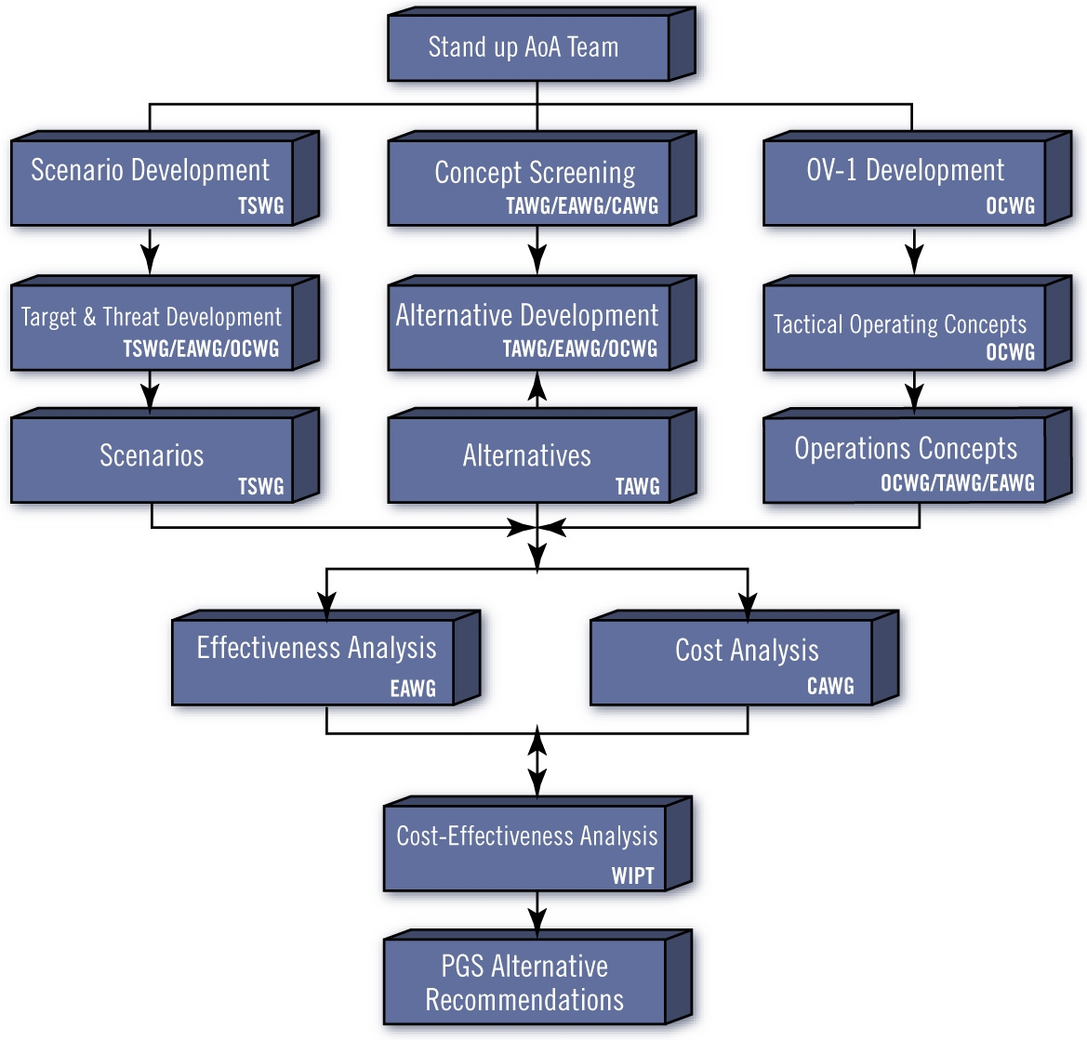
Figure 2-2. Overall AoA Approach

The WGs designated in the lower corner of each box in the diagram prepare their inputs for the analysis as described in Sections 3 through 9 of this plan. After the WGs have completed their initial tasks, the EAWG and the CAWG perform effectiveness and cost analysis respectively. Next, the WIPT oversees the cost-effectiveness analysis step, drawing on expertise from the WGs as required. The WIPT then reports the PGS AoA results to the AFROCC and drafts the AoA Final Report as outlined in Section 10 of this study plan. Upon completion of the AoA, the final report is delivered to OSD/PA&E. AFSPC/DR archives appropriate AoA materials for future reference.

Schedule

The PGS AoA process is expected to take approximately two years. As discussed in Section 1.3, the PGS AoA is conducted in two increments. The analysis will focus first on the no warning case (case 1) and the unambiguous warning case (case 2) will follow. As envisioned, the second case will leverage off the work accomplished in the first case (e.g., threats, scenarios, and model selection). The complexity of this Joint-interest AoA, the inter-service coordination required, and the two cases approach is likely to prevent a timeline shorter than 24 months. For a detailed milestone chart, reference Section 11.

Threats & Scenarios

Introduction

The Threats & Scenarios Working Group (TSWG) is responsible for recommending a variety of validated scenarios and vignettes that represent the spectrum of environments and range of conditions the PGS system is required to operate in, thereby avoiding bias for or against a particular concept. The TSWG fully documents scenarios to ensure that subsequent modeling and simulation findings can be presented within clear ground rules and frameworks for study results. Specific targets and threats, with their supporting performance and characteristic data, are defined and consistent with the scenarios and vignettes provided.

Scenarios

The AoA will evaluate PGS capabilities in two distinct cases, no warning and unambiguous warning. For both cases, the TSWG will consider a range of scenarios and vignettes, hereafter referred to collectively as scenarios. Scenarios considered include:

- Baseline Security Posture (BSP) Vignettes
- Homeland Defense (HLD) Scenarios
- Major Contingency Operations (MCO)
- Global Strike Assessment Scenarios (GSAS)

OSD approved Defense Planning Scenarios (Baseline Security Postures, Homeland Defense scenarios and MCOs) serve as the analytical foundation for the PGS AoA. The Assessment Scenarios for USSTRATCOM Global Deterrence and Strike Planning (hereafter referred to as GSAS) are not Defense Planning Scenarios (DPS). However, the GSASs provide a valuable setting to stress the PGS capability. Any use of GSASs will be accomplished through mapping to DPS-approved BSPs and MCOs. The majority of these scenarios involves a limited strike, such as an emerging, high-payoff target deep inside a country, requiring quick response, critical defeat, or counter WMD, responding rapidly after target identification to deliver effects within a short window of vulnerability.

While PGS capabilities are linked primarily to Global Strike missions, they may also support force employment in MCOs. For example, PGS capabilities may be employed in an MCO by striking critical air defense nodes (e.g., hardened C3 facilities) in advance of arriving aircraft, destroying longer-range theater ballistic missile and cruise missile capabilities, and destroying naval vessels that threaten the ability of US naval and amphibious forces to operate in littoral waters. PGS capabilities provide US rapid-response forces freedom to operate and mitigate an adversary’s ability to intimidate or coerce neighboring countries into denying basing or overflight rights to US forces. By projecting military power from outside an adversary’s reach, the US can also directly attack centers of gravity and other high-payoff targets early in the conflict.

The scenarios selected for AoA analysis will be assessed in the context of the emerging challenges as described in both the National Defense Strategy and the National Military Strategy of the United States:

  - Traditional. Conventional air, sea, and land challenges represented by states employing legacy and advanced military capabilities and recognizable military forces, in long-established, well-known forms of military competition and conflict.
  - Irregular. Unconventional methods adopted and employed by non-state and state actors to counter stronger state opponents (terrorism, insurgency, civil war, extremism, militancy, coercion, etc.).
  - Catastrophic. Destabilizing capabilities outside “rational” control. These challenges involve the surreptitious acquisition, possession, and possible terrorist or rogue employment of WMD or methods producing WMD-like effects.
  - Disruptive. Challenges that emanate from competitors developing, possessing, and employing “breakthrough” capabilities and tactics, techniques, and procedures that suddenly undermine US superiority.

Targets

The PGS AoA focuses on high-payoff, time-sensitive targets consistent with the selected scenarios. The target set may be either fixed or mobile (not moving, but can move) and most likely includes:
- WMD (e.g., production storage, launch facility, delivery)
- Leadership Elements
- Critical infrastructure (e.g., command and control facilities, communications, power plants, POL storage)
- Counterspace capabilities
- Critical anti-access nodes (e.g., key ships, IADS, etc)
- Airfields, ports, and choke points (Lines of Communication)
- Global War On Terrorism (GWOT) targets, though not technically a target set in itself, may contain target types from various target sets, typically considered high-payoff. GWOT targets may require time sensitive execution, special intelligence, or limited collateral damage compared to other target types.
- HDBTs (not technically a target set in itself, but typically considered high-payoff and likely hard and deeply buried). Attacking HDBT’s present different challenges than surface targets and require a separate category.

Threats

As described in Defense Intelligence Agency’s (DIA) Global Assessment: 2020, the progression of world events up to the 2020 time frame are characterized by turmoil with more challenges to US interests, diffused power relationships, less cohesive and sustainable alliances, and emerging forms of warfare. Historic rivalries continue to provoke crises, in which increasingly more assertive and capable entities (including non-state, non-traditional actors) vie for greater influence within their geographic regions.

The migration to this 2020 threat has already begun. A few advanced military states are experimenting with new operational and organizational concepts to exploit information warfare, offensive counterspace, and precision strikes. Other states are seeking to offset adversary advantages by pursuing asymmetrical response strategies. Countries are expected to favor cruise missile and ballistic missile systems to address their regional security concerns without the expense of large strike-oriented air forces. The proliferation of WMD technologies and the means to deliver them may well be the most serious challenge for the US and its allies. Although WMD can be delivered via a number of rudimentary delivery systems, the combination of WMD warheads with theater ballistic missiles or cruise missiles allows an adversary to extend their operational reach. In the future, the threat is increasingly from states of concern, non-state terrorists, extremists, and/or criminal groups with inventories of WMD and uncertain inhibitions about using them.

In addition to the increasing offensive threats, improvements in defensive capabilities are expected. This includes more capable surface-to-air missiles (SAM), electronic countermeasures to jam Global Positioning System-based systems, information operations and command and control warfare.

Detailed threat descriptions are contained in the following documents:

- Global Assessment: 2020 (U), DI 1570-6-00, June 2000, National Intelligence Estimate (NIE) 97-13/1, October 1997
- Chemical and Biological Warfare Capstone Threat Assessment (U), DI-1650-83-02, February 2002
- ICBM System Threat Assessment Report (U) NASIC-1574-0950-02, January 2002
- Additional information is available in an Appendix to the Space Capstone, due to the published in Jan 2006
- Interim Space Capstone Threat Capabilities Assessment (U) NAIC-1574-0727-03, July 2003
- Air Combat Threat Environment Description (U) NAIC-1574-0730-02, February 2002
- Naval Strike and Air Warfare Systems (U) ONI-TA-017-02 Vols 1 & 2, May 2002 and January 2003
- Information Operations (IO) Capstone Threat Capabilities Assessment (U) DI-1577-31-05, March 2005.
- Nuclear Capability Projection for the Non-Declared Nuclear Weapons States and Selected Rest of World Nuclear Programs: 1999-2018 (U), DI-1610-22-99-SI, May 1999

Strategic Security Environments

According to the National Military Strategy of the United States of America, 2004, adversaries capable of threatening the US, its allies and its interests range from states to non-state organizations to individuals. There are states with traditional military forces and advanced systems, including cruise and ballistic missiles, which could seek to control key regions of the world. A few of these states are “rogues” that violate treaties, secretly pursue and proliferate WMD/E, reject peaceful resolutions of disputes and display callous disregard for their citizens. Some of these states sponsor terrorists providing them financial support, sanctuary and access to dangerous capabilities. There are non-state actors, including terrorist networks, international criminal organizations and illegal armed groups that menace stability and security. Even some individuals may have the means and will to disrupt international order. Some of these adversaries are politically unconstrained and, particularly in the case of non-state actors, may be less susceptible to traditional means of deterrence. Adversaries increasingly seek asymmetric capabilities and use them in innovative ways. They avoid US strengths, like precision strike, and seek to counter US power projection capabilities by creating anti-access environments. Such adversaries target civilian populations, economic centers and symbolic locations as a way to attack US political will and resolve.

Adversaries threaten the US throughout a complex battlespace, extending from critical regions overseas to the homeland and spanning the global commons of international airspace, waters, space and cyberspace. There is a region of instability stretching from the Western Hemisphere through Africa and the Middle East and extending to Asia. There are areas in this region that serve as breeding grounds for threats to our interests. Within these areas, rogue states provide sanctuary to terrorists, protecting them from surveillance and attack. Other adversaries take advantage of ungoverned space and under-governed territories from which they prepare plans, train forces and launch attacks. These ungoverned areas often coincide with locations of illicit activities; such coincidences create opportunities for hostile coalitions of criminal elements and ideological extremists. The US will conduct operations in widely diverse locations—from densely populated urban areas located in littoral regions to remote, inhospitable and austere locations. Military operations in this complex environment may be dramatically different than the high intensity combat missions for which US forces routinely train.

While US Armed Forces’ continue to emphasize precision, speed, lethality and distributed operations, commanders must expect and plan for the possibility that their operations will produce unintended second- and third-order effects. For example, US forces can precisely locate, track and destroy discrete targets to reduce collateral damage and conclude operations as quickly as possible. Operations that rely on precision may result in large elements of an adversary’s military remaining intact and segments of the population unaffected.

Commanders must prepare to operate in regions where pockets of resistance remain and there exists the potential for continued combat operations amidst a large number of non-combatants. This battlespace places unique demands on military organizations and interagency partners, requiring more detailed coordination and synchronization of activities, both overseas and at home. Our experiences in Afghanistan and Iraq highlight the need for a comprehensive strategy to achieve longer-term national goals and objectives.

The US must adopt an “active defense-in-depth” that merges joint force, interagency, international non-government organizations and multinational capabilities in a synergistic manner. This defense does not rely solely on passive measures. The US must enhance security at home while actively patrolling strategic approaches and extending defensive capabilities well beyond US borders. An effective defense-in-depth must also include the capability to strike swiftly at any target around the globe using forces at home, as well as forward-based, forward-deployed and rotational forces.

Methodology

Beginning with National Security Strategy (NSS) at the highest level and the Strategic Planning Guidance for a strategic framework and general description of potential military operations and various contingencies throughout several areas of the world, Defense Planning Scenarios (DPS) are used as starting points for scenario selection. Multi-Service Force Deployment (MSFD) products are DoD-approved theater campaign sets of ally and threat scenario data describing in detail the full spectrum of conflict for future postulated scenarios outlined in the DPS.

The MSFD and DPS are integral portions of DoD Analytic Baselines and form a standardized foundation for Department and DoD Component strategic analysis in the mid-term (end of FYDP) and far-term (2024).

The TSWG is cognizant of the fact that the USSTRATCOM Representative Global Strike Target List is a set of current year targets; the Global Strike, BSP and HLD scenarios are set in the near- and mid-term; the MCOs are set in the mid- and far-term; and the PGS epoch year is 2020. The TSWG will consult with appropriate intelligence agencies, production centers, and OSD/PA&E, to reconcile any threat and scenario issues resulting from disconnects in the referenced time frames.

Scenario Selection Process

The scenario selection process will be performed for both case 1 and case 2. Although the processes are somewhat different for the two cases, the TSWG will leverage case 1 analysis to minimize duplication of effort and to assist in delivering the appropriate scenario recommendations for each case.

Stressor Matrix

The scenario selection process for both case 1 and case 2 begins with the development of a PGS Stressor Matrix. These stressors (i.e., defining parameters and the threat environment in which the PGS system are most likely employed) are those characteristics that, if contained in a scenario, would stress the potential capabilities of any PGS AoA solution. These stressors can be grouped into five broad categories:

- Time Sensitive
- Extended Reach
- Hard Target Strike
- Active Defense/Denied Access
- Non-Active Defense & Restrictions

Once a comprehensive list of stressors (along with descriptions and clarifying information) is finalized, a weight of 1, 3, or 9 (corresponding to low, medium or high) will be assigned (see Table 3-1).

Table 3-1. PGS Stressor Weighting Definitions
Score | Definition
High | Those stressors that absolutely must be present in the scenario to adequately represent the capability challenges that potential solutions must overcome.
Medium | Those stressors that must be considered during the AoA study and should be present in the scenario, but are not necessarily new or significant capability challenges.
Low | Those stressors that should be included in the scenario if available, but do not significantly impact the AoA study.

These stressors will later be scored against the suite of scenarios (described above in section 3.1.1) as to there presence in each scenario. This matrix is used to evaluate the efficacy of MCO, BSP, HLD and GSAS scenarios.

Case 1: No Warning

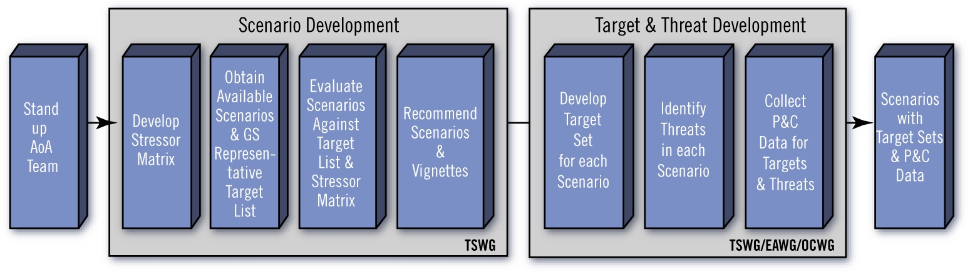
Figure 3-1. Threat and Scenario Development

Scenarios will be evaluated in a three step process. In Step One, the TSWG performs a preliminary screening of all available MCO, Global Strike, BSP, and HLD scenarios in relation to the USSTRATCOM Representative Global Strike Target List. This target list consists of 115 real-world targets, categorized into seven focus areas. The TSWG subjectively scores candidate scenarios against this target list, assigning a score of 0, 1, and 2. A “0” indicates the scenario does not have the potential to contain that particular target; a “1” indicates the scenario has the potential to contain that type of target, but the scenario country and target location don’t match; and a “2” indicates the scenario has the potential to contain that specific target. The three highest scoring scenarios in each of the seven target focus areas are carried forward to Step Two.

Table 3-2. Targets Grading Against Scenarios (Notional)

Targets | Scenarios
Targets | GSAS 1 | GSAS 1 Comments | BSP 6 | BSP 6 Comments
Target 1 | 2 |  | 0
Target 2 | 1 |  | 2
Target 3 | 2 |  | 1
Target n
Overall Rating Score | 5 |  | 3

The numbers in Tables 3-2 are notional and provided for illustrative purposes only. The actual results are classified SECRET//NOFORN and are maintained separately.

In Step Two, the down-selected scenarios are subjectively scored by the TSWG against the PGS Stressor Matrix. Because the Global Strike, BSP and HLD scenarios lack the details and MSFD products associated with the MCOs, these scenarios are only scored against the stressor categories, receiving a 0, 1 or 2. In this exercise, a “0” indicates none of the sub-stressors (individual stressors within the stressor category) exist in the scenario; a “1” indicates at least one of the sub-stressors exists; and a “2” indicates two or more sub-stressors exist in the scenario.

Table 3-3. PGS Stressor Matrix (Notional)

Stressors | Scenarios
 | Weight | GSAS 11 | BSP 2 | BSP 7 | MCO 2
Stressor Category 1 | 9 | 0 | 2 | 0 | 2
Stressor Category 2 | 3 | 2 | 2 | 0 | 2
Stressor Category 3 | 1 | 2 | 1 | 1 | 2
Stressor Category n
Overall Rating Score |  | 8 | 25 | 1 | 26

The numbers in Tables 3-3 are notional and provided for illustrative purposes only. The actual results are classified SECRET//NOFORN and are maintained separately.

The highest scoring scenarios in each of the stressor categories are cross-referenced to the results of Step One to ensure the scenarios in the final recommendation: 1) fully stress the desired PGS capabilities, and 2) address all seven target focus areas. It is possible that less-stressing scenarios may be combined or otherwise added to the recommendation in order to fill any identified gaps.

Case 2: Unambiguous Warning

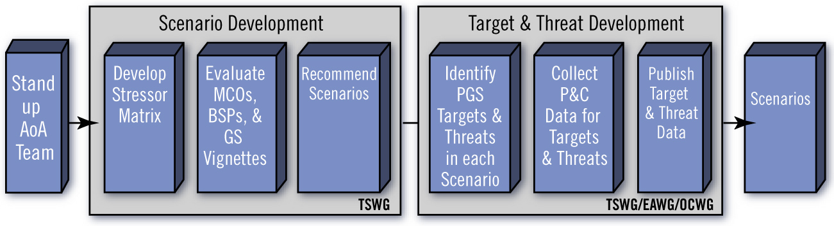

Figure 3-2. Threat and Scenario Development

The TSWG subjectively evaluates the scenarios against the full PGS Stressor Matrix, assigning a rating of 0, 1, or 2 to each stressor. A “0” indicates the stressor is not present in the scenario; a “1” indicates the stressor is present, but not a significant factor; and a “2” indicates the stressor is present and a significant factor of the scenario. Subtotal and overall scores are calculated and analyzed to determine the final scenario recommendation. It is possible a less-stressing scenario may be included in the recommendation if it is the only scenario to significantly stress a desired capability.

Table 3-4. MCO Scenario Grading Against Driving Factors (Notional)

Driving Factors | Weight | Scenario |  |  |  | Comment
Driving Factors | Weight | MCO-1 | MCO-2 | MCO-3
Time Sensitive
Mobile | 9 | 1 | 1 | 0
Time Constrained | 9 | 0 | 0 | 2
TBD | 9 | 1 | 0 | 0
Subtotal |  | 18 | 9 | 18
Extended Reach
TBD | 9 | 1 | 2 | 1
Subtotal |  | 9 | 18 | 9
Hard Target Strike
TBD | 3 | 2 | 1 | 2
Subtotal |  | 6 | 3 | 6
Active Measures of Defense
TBD | 3 | 2 | 1 | 1
Subtotal |  | 6 | 3 | 3
Non-Active Defensive Factors & Restrictions
TBD | 1 | 2 | 1 | 1
Subtotal |  | 2 | 1 | 1
Overall Rating Score |  | 41 | 34 | 37

The numbers in Tables 3-4 are notional and provided for illustrative purposes only. The actual results will be classified SECRET//NOFORN and are maintained separately.

Defense Challenges

To ensure PGS concepts are evaluated across the full spectrum of global threats and challenges, the selected scenarios in Table 3-4 will be assessed against the defense challenges, the new threat paradigm. A subjective rating of 2, 1, or 0 (corresponding to primary, secondary or non-applicable) will be applied to each of the scenarios chosen. Per the example shown in Table 3-5, GSAS 5 was determined to be primarily (2) a “disruptive” scenario, with “catastrophic” identified as a secondary (1) challenge.

Table 3-5. Defense Challenges Graded Against Scenarios (Notional)

Challenge | Scenarios
Challenge | GSAS 5 | BSP 2 | BSP 10 | HLD 2 | MCO 1
Catastrophic | 1 | 0 | 0 | 2 | 0
Disruptive | 2 | 1 | 1 | 0 | 0
Irregular | 0 | 0 | 2 | 1 | 1
Traditional | 0 | 2 | 0 | 0 | 2

The numbers in Tables 3-5 are notional and provided for illustrative purposes only. The actual results are classified SECRET//NOFORN and are maintained separately.

Once again, it is possible that a less-stressing scenario may be combined or otherwise included in the final scenario recommendations in order to fill any identified gaps.

Scenario Recommendations

The final scenario recommendations will be delivered to the WIPT for approval. The TSWG will ensure the recommended scenarios fully stress PGS capabilities across the spectrum of threats and challenges. The TSWG will also deliver scenario summaries, associated scenario timeline, and any applicable MSFD products to the other WGs as required.

Target and Threat Development

Once the scenario recommendations are approved, the TSWG leads a team in developing target sets for each scenario. The team consists of members from the OCWG, EAWG, USSTRATCOM, the Services, NASIC, DTRA, and other national agencies, as deemed appropriate. The team will review other studies, such as the NGLRS-II AoA and J8 CBA scenarios and target sets, for any applicable insights.

For case 1, the USSTRATCOM Representative Global Strike Target List will serve as the main resource for target set development. In cases where a particular target type called for in a scenario is not suitably represented in the USSTRATCOM target list, a more appropriate representative target will be sought.

For case 2, the target sets are derived in accordance with scenario guidance and COCOM inputs.

The TSWG will ensure the combined target sets for both case 1 and case 2 include targets from all seven of the USSTRATCOM target focus areas and will deliver selected threat system and target performance and characterization (P&C) data to the other WGs as required.

Deliverables

- Study Plan inputs
- Stressor Worksheet
- Scenario Recommendations
- The TSWG will provide the AoA WIPT with products to more completely define the recommended scenarios. These products may include:
  - Scenario Summaries and Timeline
  - MSFD documents with supporting data
  - Target list database
  - Collection management plan (CMP), if necessary
  - Threat and target P&C information
- Progress Report inputs
- Final Results Briefing inputs
- Final Report inputs.

Technology & Alternatives

Introduction

The TAWG is responsible for generating concepts and in conjunction with the EAWG, developing alternatives for the AoA. The TAWG ensures the concepts assessed and final alternatives analyzed, are consistent with OCWG operating concepts and CAWG initial cost factors. The TAWG formulates Technical Description Documents to serve as the repository for all concept and alternative data for the AoA.

Studies

Listed below are several studies performed by various organizations that highlight/describe prompt global strike characteristics. While their conclusions recommended a variety of specific approaches, the findings consistently support the need for precision effects against high-payoff targets with non-nuclear weapons and very rapid, long-range (theater and/or global) response. The PGS AoA studies a culmination of these characteristics to provide decision-makers clear recommendations on the utility of a prompt global strike solution set. The TAWG and the EAWG will leverage previous study results as appropriate.

Studies
Strike Mission Area Studies 2002 ASC
Analysis of Future Long-Range Strike (LRS) Capabilities Ph 1, 2 2003 IDA
Long-Range Global Precision Engagement 2003 DoD/ACC
Future Strategic Strike Forces 2003 DoD
Immediate Attack Deep Inside Hostile Territory 2003 AF SAB
Military Utility Analysis-AFSPC CAV 2003 AFSPC
Near & Mid-Term Capabilities/Improving LRS 2003 RAND
CONOPS & Technology to Support LRS Operations 2003 AF SAB
Hard & Deeply Buried Target Defeat AoA 2003 AFSPC
Operational Availability 2004 2004 DoD
Operationally Responsive Spacelift AoA 2004 AFSPC

Methodology

In this study, the term concept refers to an end-to-end operational system representation (e.g., Hypersonic Cruise Vehicle, its launch platform, payload, and supporting infrastructure). All concepts must consider the integration of weapon systems and enabling capabilities. An alternative may consist of a single concept or combination of concepts. Alternatives are concepts refined and synthesized into a limited number of alternatives that fit within the defined PGS operational architecture.

TDDs are the basic documents for describing a concept or alternative. The TAWG develops TDDs for all PGS concepts and alternatives in an iterative process with the other WGs. The TAWG provides clarification and modification to elements in the TDDs as requested. There are three levels of TDDs:
    - A Level I TDD is a system description in a quad-chart format, adequate to provide the basic characteristics differentiating one system from another;
    - A Level II TDD is a more descriptive document, which facilitates first-order screening and analysis;
    - A Level III TDD is a description of the proposed system and its operating characteristics in sufficient detail for modeling and cost analysis.

Examples of elements needed for the TDD (Level III) include:
- Data appropriate to populate effectiveness and cost models as identified by the EAWG and CAWG respectively;
- Reliability of space, air, and/or surface components;
- Operational life of space, air, and/or surface components in order to determine the replacement period;
- System replacement and technology refresh of space, air, and/or surface components;
- Acquisition strategy issues, such, as sharing costs with other programs, implementation schedule, contracting approach, overall management of risks and incremental spiral evolution;
- Development approach, such as using commercial off-the-shelf (COTS) items versus developed software, using government furnished equipment, or using legacy hardware and software.

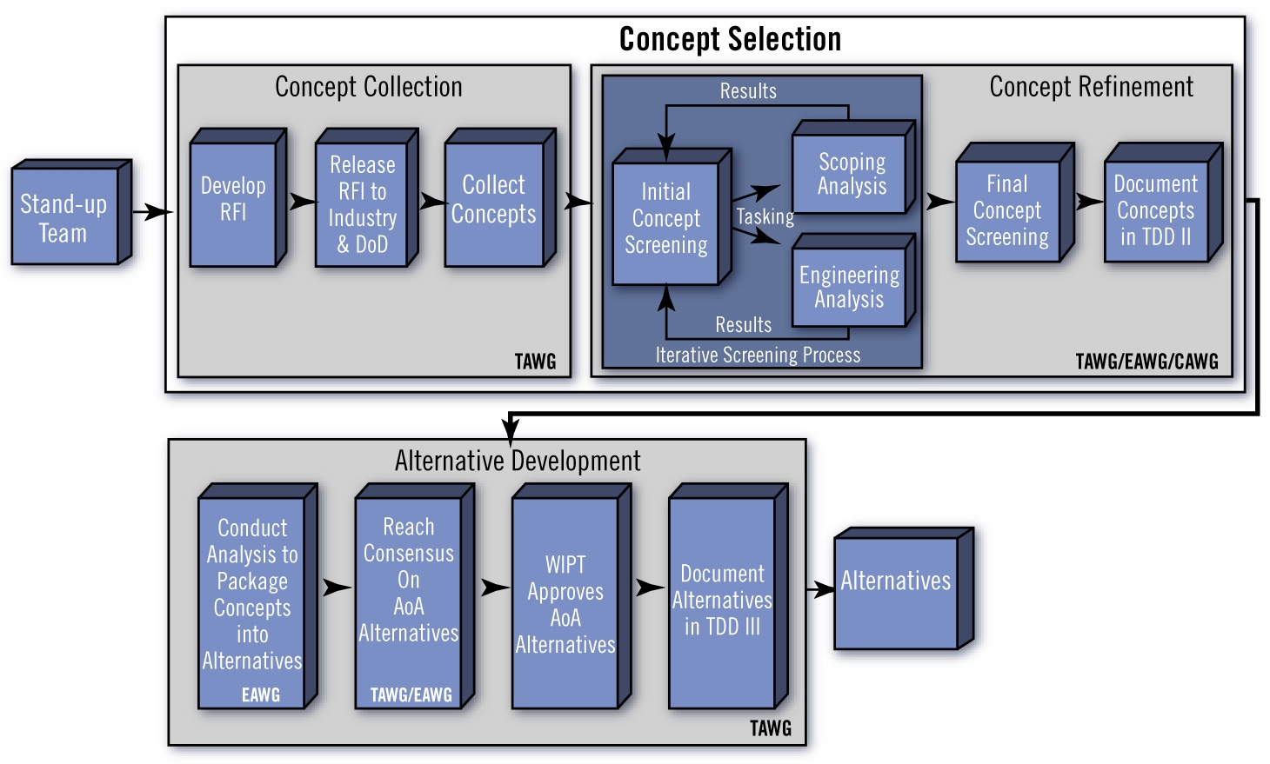
Figure 4-1. Concept and Alternative Development

Concept Selection

As depicted in Figure 4-1, the TAWG collects concepts through the issuance of a Request for Information (RFI) to industry, services, and national laboratories. These concepts are analyzed and screened using subject matter expertise, modeling and simulation, and other analytical tools as determined by the TAWG and EAWG. The viable concepts are grouped according to capabilities to cover the trade space. If there are multiple variations of a concept, the TAWG performs the analysis necessary to synthesize them into a “best of breed” concept.

As currently envisioned, the TAWG will issue an RFI soliciting concepts to address the PGS “no warning” case. AFSPC/DR will determine when a subsequent RFI addressing the unambiguous warning case is required. The approach is to establish concepts that represent a range of capabilities and cost in the trade space that encompasses both service-specific and joint solutions. The TAWG develops a Level II TDD from each submission. While all concepts submitted through the RFI process are considered, not all concepts become part of the alternatives analyzed by the AoA. The criterion used to evaluate the concepts is developed by a joint sub-group of the TAWG. The criterion include, but are not restricted to such factors as Technology Readiness Levels (TRL); feasibility, to include broad effectiveness of the concept in relation to some of the capabilities listed in Section 6.2.1; rough order magnitude cost; schedule; basing; as well as other pertinent measures identified by the joint sub-group.

In the case of TRLs and system capability claims made by concept submitters, the accuracy of the claims and potential risks associated with the technologies is assessed both qualitatively, based on subject matter experts’ past experience, and quantitatively, through: 1) engineering analyses directed by the TAWG and, 2) scoping analyses accomplished by the EAWG as requested by the TAWG. These analyses are accomplished iteratively, as needed, to support the initial screening process in the Concept Refinement phase of the TAWG effort. A brief discussion of these analyses follows:

Engineering Analyses. Where appropriate, engineering analysis to verify claims of system capability made by concept submitters is performed. All engineering analyses are carried out by analysis offices identified and sanctioned by the TAWG. Results of these assessments for given technologies and stated capability claims, are weighed accordingly by the TAWG in the selection or rejection of a given concept.

Scoping Analyses. The EAWG performs scoping analyses, as required, to assist in bounding the concept trade space. The scoping analyses help determine if a concept is considered feasible by evaluating, on a gross scale, system capability. The scoping analyses include evaluation of broad system capability against such capabilities as global range, promptness, and payload accuracy. Like the results of the engineering analyses, the results of the scoping analyses provide additional justification to the TAWG in the selection or rejection of a given concept.

Justification for rejection of a given concept is documented in a TDD. Concepts selected for consideration in the Alternative Development phase of the TAWG process are also documented in a TDD. The selected concepts are then provided to the EAWG for initial evaluation to establish rationale for the development of preliminary alternatives.

Alternative Development

The goal is to build a set of alternatives (preferably 3-5 sets for manageability) that represent the family-of-systems trade space. While the TAWG expects that most of the alternatives selected for detailed effectiveness and cost analysis are a mixture of different, but mutually supporting concepts, it is possible that a single concept could stand on its own as an alternative. The process for determining what concepts are included in the alternatives evaluated proceeds as follows.

The EAWG, with inputs/constraints from the TAWG/OCWG/CAWG, run models to support the TAWG in the evaluation of combining concepts into alternatives. Based upon EAWG analysis, the EAWG provides initial alternative recommendations to the TAWG. In concert, the TAWG and the EAWG reach agreement on the details of the final alternatives. The EAWG also identifies data requirements necessary to populate the EAWG models selected through the process outlined in Section 7.4, Models and Data. The TAWG submits the final alternatives for each case to the WIPT for approval prior to effectiveness analysis. The Study Director ensures the alternatives are taken through the appropriate levels of internal and external approval. The TAWG documents each of the final alternatives in a Level II TDD, summarizing the combat capability provided by each alternative. A Level III TDD, that includes modeling and cost parameters for each concept included in an alternative, is then developed by the TAWG. After WIPT approval, the TDDs are provided to the EAWG to perform effectiveness analysis; the OCWG for matching with tactical operating concepts; and to the CAWG to support cost analysis. The TAWG maintains configuration control of the alternatives through the TDD process. The TAWG will re-visit the above process for the unambiguous case, leverage what we’ve learned from the no warning case, and modify the process as appropriate.

Baseline Alternative

The TAWG supports the OCWG in development of the baseline alternative. The President’s Budget FY 06-11 serves as the source document for establishing the baseline alternative. The TAWG documents the baseline alternative in a TDD. The process to identify the concepts within the baseline is found in Section 5.2.2.

The TAWG supports the OCWG in development of the baseline alternative. The President’s Budget FY 06-11 is the reference in developing the baseline. The OCWG compiles and summarizes the baseline, submitting the document to the TAWG for configuration control and distribution purposes. Technical detail for modeling purposes in support of the EAWG is compiled in a TDD III, as necessary, by the TAWG. The process to identify the concepts within the baseline is found in Section 5.3.

Description of Alternatives

Listed below are examples of concept types described in the PGS ICD. Although Information Operations (IO) and Directed Energy (DE) are listed in ICD as potential materiel alternatives, they will not be evaluated during the course of the AoA, per direction of OSD. The complexity of IO and the readiness of DE technologies necessitate the removal of these alternatives from consideration. The final set of alternatives, resulting from the alternative development process described in section 4.2.2, may be a combination of the concepts described below, or may include concepts not mentioned in the ICD. The final set of alternatives is documented in TDDs.

- Baseline. The baseline force in the AoA is the President’s Budget FY 06-11. The analysis team will reference the QDR, DPG, and the Joint Strategic Capabilities Plan to provide insight on determining forces available in scenarios and the doctrine of deployed forces.
- High Speed Strike Systems. This approach requires development/adaptation of a piloted, remotely controlled, or autonomous subsonic/supersonic/hypersonic vehicle (aircraft, sea craft, or missile) to deliver precision standoff or direct attack subsonic/ supersonic/ hypersonic munitions.
- Operationally Responsive Space. An expendable and/or reusable launch vehicle that can deliver precision guided munitions.
- Military Space Plane. A reusable launch vehicle that could directly deliver precision guided munitions.
- Ground or Sea-based Expendable Launch Vehicle. This approach consists of either modification of current space launch vehicles, conversion of deactivated intercontinental ballistic missiles or sea-launched ballistic missiles, or building a new launch vehicle to deliver weapon payloads; such as small launch vehicle or submarine launched intermediate range ballistic missiles. An advanced reentry vehicle/body; such as, a common aero vehicle could be developed to accompany these missile systems.
- Air-Launched Global Strike System. This concept consists of an aircraft that air-launches Pegasus-like space launch vehicles configured with weapons and/or an aircraft delivering supersonic or hypersonic long-range cruise missiles.

Deliverables

- Study Plan inputs
- RFI
- Final list of alternatives
- A TDD for each concept
- A TDD for each alternative, including the baseline alternative
- Justification for each non-viable concept documented in a TDD
- Input to the EAWG for the scoping analysis
- Input to the CAWG for the work breakdown structure (WBS) for each alternative
- Input to the OCWG for tactical operating concepts for each alternative
- Progress Report inputs
- Final Results Briefing inputs
- Final Report inputs

Operations Concepts

Introduction

The Operations Concepts Working Group (OCWG) is responsible for developing the overarching operational view (OV), identifying the baseline alternative, and developing broad operating concepts for each analysis scenario and specific operating concepts for each PGS alternative selected for evaluation. The OVs are relatively broad in scope. The operating concepts for each of the alternatives are more specific and support the needs of the EAWG, TAWG, TSWG, and CAWG. Applicable “C4ISR” elements and intelligence support requirements are included as necessary for each concept/alternative. The final operations concepts are a combination of the OVs and the alternative operating concepts in a single document.

Methodology

The OCWG gathers CONOPS and concept documents already approved or in draft to use as the foundation for the OV-1 and the alternative operating concepts. This is an ongoing task. Documents include CONOPS/concepts from the Joint community, AF-level organizations, AFSPC, ACC, the other Services, and other agencies as required. The OCWG reviews documents for applicability and inclusion in the OCWG library. These documents provide the general construct for developing specific operating concepts for the alternatives.

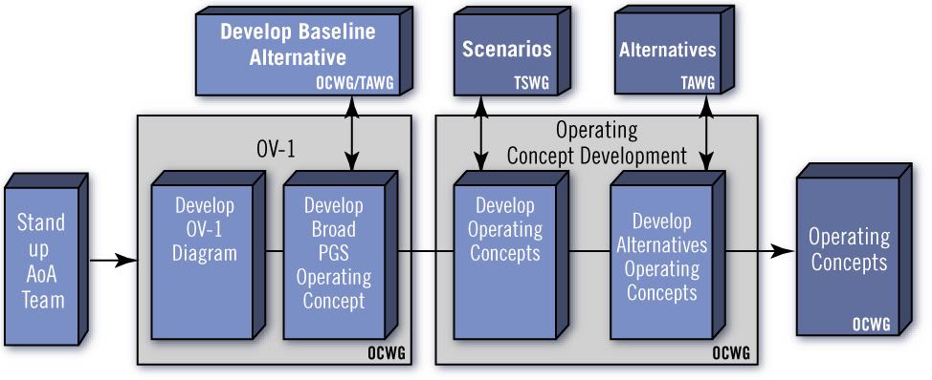
Figure 5-1. Operating Concept Development

Operational Views Development

The OV-1 block in Figure 5-1 represents the overarching OV-1 developed for the PGS ICD (see figure 5-2). This is relatively broad in scope and not tied to specific PGS concepts. The overarching OV-1 is used to provide general guidance to the TAWG as they develop specific PGS alternatives for evaluation.
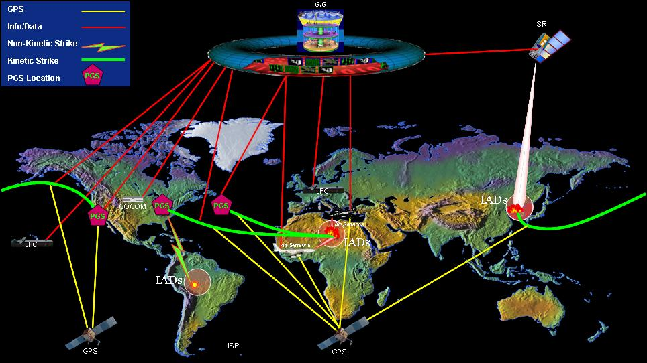
Figure 5-2. Overarching PGS Operational View

As depicted in Figure 5-2, ISR assets, tasked through current procedures, provide data disseminated through GIG systems such as MILSATCOM and are converted to targeting data at one or more locations (e.g., USSTRATCOM). The designated commander tasks PGS assets to meet national objectives. A PGS asset may execute in a manner similar to the way other strike assets (e.g., CALCM, or TLAM) are tasked today. Planners using tools connected via the GIG identify PGS assets, asset status, and mission capability. Targeting data is transmitted via the GIG directly to the PGS asset operating location. Following COA development, the specified PGS (kinetic or non-kinetic) system will then deliver effects on target following receipt of the execution order. One of the key attributes of a PGS concept is its ability to penetrate anti-access systems, illustrated in the OV-1 as IADs.

Battlespace awareness tools provide near real-time status on PGS assets and target sets. ISR assets (including any assets organic to the PGS system) provide BDA information fed back through the GIG for the next planning cycle.

Baseline Alternative Development

The baseline serves as the “yardstick” of the analysis effort. The baseline force structure represents the capabilities the US currently uses to answer the PGS mission need. The strike systems funded, and either currently in place or achieving IOC in the President’s Budget (PB) FY 06-11, are the reference for forming the baseline architecture for this analysis. The OCWG, with support from the TAWG, leads the effort to identify the concepts within the baseline architecture and provides an operations concept, including identification and linkages to the necessary C4ISR architecture. The baseline alternative TDD is drafted by the OCWG and maintained by the TSWG along with the other alternative TDDs.

Using the overarching PGS OV1 as a backdrop, the OCWG reviews, in coordination with USSTRATCOM, the PB FY 06-11 to determine what capabilities the US currently possesses that may be able to provide a prompt global strike. The OCWG also references the QDR, DPG, and the Joint Strategic Capabilities Plan to provide insight on determining forces available in scenarios and the doctrine of deployed forces. Standard basing, as defined in the Strategic Planning Guidance, is included as part of the baseline definition. Standard basing is used to evaluate system feasibility, as outlined above, in concept screening and alternative development. The operating concept for the baseline alternative is then developed.

The baseline alternative and operating concept are reviewed by the WIPT (to include USSTRATCOM representation) and OSD for accuracy and consistency.

Operating Concepts Development

The broad operating concepts for each PGS scenario provided by the TSWG and the specific PGS alternatives provided by the TAWG are culminated in the PGS Operations Concept. The operating concepts for each alternative provide enough detail to support EAWG needs.

The OCWG, in coordination with the TSWG, EAWG and COCOM guidance, determines the priority of targets in the scenarios studied. C4ISR elements are included in the operating concepts as required by the analysis approach. The operations concepts also provide detail necessary to support the CAWG. Close coordination is required between the OCWG, TAWG, EAWG, TSWG, and CAWG. Level of detail is dependent on the specific analysis methodology and tools used to support the effectiveness analysis. The concepts may include the following information:

- A description of the information flow from origin of tasking through mission planning, data down-linking, processing, exploitation and dissemination of mission data and information to include graphical portrayals of the data/information flows.
- Timelines that document how the alternative will satisfy or meet the classified PGS timelines contained in the PGS ICD.
- Data links and nodal mapping of all points in the information flow as defined within each alternative/concept.
- Dynamic tasking and re-tasking concepts for time sensitive targeting, strike and tactical mission tasks.
- The broad scheme for integrating the alternative with existing and projected systems to include C4ISR.
- A general description of integration/interoperability with DoD and intelligence community systems and capabilities.
- Interdependencies with existing operational support systems (navigation, communications, weather, etc)
- Deployment concepts to include timelines and replenishment concepts.
- Vulnerability mitigation strategies and estimated operational constraints
- Basing and projected infrastructure requirements

The OCWG identifies other information for inclusion in the concepts as the effectiveness analysis approach progresses.

Operations Concepts Documentation

The OCWG develops operating concepts during the AoA as scenarios, alternatives and analysis plans are defined and developed. The operations concepts are a combination of the OVs, the broad scenario and specific alternatives operating concepts in a cohesive document for each alternative. The OCWG will review and revise the operations concepts, as appropriate, for case 2.

Deliverables

- Study Plan inputs
- Target Type input to TSWG with update as necessary
- Stressor Matrix inputs to the TSWG
- Library of existing concept documents (CONOPS, functional, enabling, etc.)
- Identification of the AoA baseline (in conjunction with the TAWG)
- Overarching PGS Operational Views (OV)
- Broad operating concepts for each scenario
- Target prioritization
- Specific operating concepts for each alternative
- Incorporation of alternatives in current C4ISR architecture
- Intelligence support requirements and/or shortfalls tailored to specific PGS alternatives
- Proposed solution approach for identified intelligence shortfalls
- Operations concepts document
- Progress Report inputs
- Final Report inputs
- Final Results inputs

Measures of Effectiveness

Introduction

The Effectiveness Analysis WG is responsible for developing metrics that define and measure the performance of each alternative. These metrics flow down from the PGS ICD which provides the context for evaluation of the alternatives. The commander’s intent for PGS targets is translated into capabilities. Measures of Effectiveness (MOE) are then developed to provide a quantitative means to measure how well the mission capabilities are satisfied, and to compare the effectiveness of concepts in each scenario considered. Measures of Performance (MOP) provide scenario-independent measures that illustrate specific aspects of concept performance. Since concepts with similar MOPs can be expected to provide similar effectiveness, MOPs can be very useful in establishing the set of alternatives to evaluate in the AoA.

Methodology

The EAWG used a critical thinking methodology adapted by AFSPC/XPY to develop its effectiveness measures for the PGS AoA. A critical-thinking working meeting was held from 28-30 June 2004. The WIPT members included the working group chairs from the TAWG, OCWG and TSWG in addition to the PGS Study Director. The EAWG members included personnel from Air Combat Command, the Navy, the Defense Threat Reduction Agency (DTRA), United States Strategic Command (USSTRATCOM) and OAS. The team produced the capabilities and MOEs. Subsequent guidance from OSD PA&E resulted in some minor revisions to the MOEs and is reflected in the list below. As alternatives and scenarios are defined during the AoA process, additional or revised MOEs maybe submitted to the WIPT from the EAWG for approval. The following list of Capabilities and MOEs are for case 1; the EAWG will review and revise the MOEs, if necessary, for case 2.

Capabilities

Traditionally, in AoAs, mission tasks (MT) are derived from the ICD with MOEs assigned to each MT to provide a quantitative way to assess the MTs. During the critical-thinking review process documents referenced in the new JCIDS requirements development process were reviewed for applicability in this AoA. These documents are the OSD linkage in the development of the ICD requirements document under the new process. An ICD for PGS is in development concurrently with this Study Plan. Several of the supporting documents dealing with Global Strike refer to capabilities rather than MTs. During the critical-thinking review the decomposition of capabilities instead of MTs was determined to be more in line with the Joint and OSD supporting documentation for Global Strike. OAS participated in this discussion and concurred with the change in traditional MT structure. The following capabilities were derived from the relevant PGS mission needs and supporting documentation and are applied to warfighter objectives in the scenarios:

CAP-1 – Global reach
CAP-2 – Prompt execution
CAP-3 – Multi-theater execution (robustness)
CAP-4 – Survivability and reliability (weapon and delivery system)
CAP-5 – High-payoff target defeat
CAP-6 – Interoperability (linkage to C4ISR, etc)
CAP-7 – Precision effects

Using these capability categories and the TAWG criterion developed for concepts, the EAWG performs scoping analyses to identify the trade space for a PGS system. The EAWG provides the results of the scoping analyses to the TAWG to assist in the concept screening and alternative development process.

Effects to Achieve

For the purposes of this AoA, the EAWG analyzes the kinetic “strike” related effects. As highlighted in Section 4.3, the EAWG will not evaluate Directed Energy or Information Operations alternatives.

Measures of Effectiveness (MOE)

MOEs provide quantifiable metrics for comparing the capabilities. Considerations in identifying MOEs are as follows:
- MOEs link effectiveness to each capability
- The number of MOEs must be manageable (not too many, not too few, and distinct from Measures of Performance)
- MOEs need to discriminate between alternatives
- MOEs are understandable and meaningful to decision makers and warfighters
- MOEs are quantifiable, through not only traditional warfighting models, but possibly value models to address decision analysis
- Additional MOEs may be identified as the study progresses
- Not all measurements produced by the models must be incorporated into MOEs

CAP 1 Global Reach.

Defined as anywhere on the globe.

MOE 1.1 – Percentage of identified targets ranged in each of the USSTRATCOM global strike mission focus areas. This MOE pertains to the number of targets that can be struck as a percentage of the target base in a given global strike mission focus area. The MOPs for this area would include range, overflight, time of flight, and targets held at risk.

CAP 2 Prompt Execution.

The PGS AoA will use the definition of prompt as described in the classified PGS ICD.

MOE 2.1 – Earliest time to engage (improved timeliness). The nominal time (from target identification to execution) to engage an adversary. Potential timeline MOPs for this area include: Course of Action Identified, Intelligence Dissemination, Develop Solution Sets, Decision to Execute and Mission Planning for Selected Solution.

MOE 2.2 – Time to effect identified targets (execution order to operational effect). The time in minutes from execution order to operational effect. Potential MOPs identified are Generation Time, Time to Execute, Time to Target and Sortie Rate.

MOE 2.3 – Success of retargeting (post-decision change of the target, abort). The ability to retarget after an initial decision has been made to execute an option. The option may be executed or awaiting execution. Anticipated MOPs for Inflight Retargeting include Message Transmission Time (origin to vehicle), Positive Control of message traffic, and System Reaction Time.

CAP 3 Multi-theater execution (robustness).

System must be capable of being targeted and executed against multiple theaters simultaneously.

MOE 3.1 – Number of multi-theater simultaneous target engagements.

CAP 4 Survivability and reliability (weapon and delivery system).

The delivery system and weapon must have both a high reliability factor and be survivable.

MOE 4.1 – Probability to penetrate under all threats (natural and man made). The weapon system (and weapon) must have a high probability to penetrate defensive systems as well as survive natural disasters or weather phenomenon. Potential MOPs include Intercept Attack, Conventional Attack (Jamming, Laser, Microwave and EMI), Natural Disasters (Fire, Flood, Earthquake and Adverse weather (terrestrial and space)).

MOE 4.2 – Weapon system reliability. The weapon system must have a high reliability consistent with current technological advances and sufficient to ensure a high degree of mission success. Potential MOPs include Communications systems, AVE/Guidance systems, Reentry System/Reentry Vehicles, Booster, and Overall Ground Equipment that could affect reliability.

MOE 4.3 – Number of PGS systems lost. This MOE speaks to the potential number of PGS systems lost due to factors such as Enemy Defensive Systems, Reliability, and Civil acts (Terrorism, Sabotage and Protestors).

CAP 5 High priority target defeat.

This capability measures the ability to defeat enemy targets of various types and complexities. The following definition is put forward to describe effects:

Probability of Kill (PK) x Probability of Arrival (PA) = Expected Kills per Sortie where;

Probability of Kill (PK) = Lethal Area of Weapon x Terminal Accuracy x Detonation Reliability x Target Hardness and;

Probability of Arrival (PA) = Probability of Penetrating Enemy Defenses x Weapon System Reliability x Energy Management.

This formula is used to measure MOE 5.1. The individual MOPs for this are explained in more detail in MOE 5.1.

MOE 5.1 – Number of high value targets commander’s desired effect achieved (by target type, total #, by time). A numeric value for given target types that includes total number of targets defeated by type and by time. Potential MOPs for this MOE are extensive.

PK MOPs may include, but are not limited to: Lethal Area of Weapon; Terminal Accuracy (Target Location Error, Guidance and Control Error, Navigation Error, Probability of Target in the Weapon’s Field of View, Probability of Target Detection, Probability of Target Identification, Probability of Target Designation, Probability of Target Prosecution, Depth/Height of Burst Accuracy, and Impact Angle/Impact Azimuth Angle); Detonation Reliability (Probability of Fuzing and Probability of Weapon Detonation); and Target (Target Hardness, Target Elevation, Target Kill Criteria, Target Size, and Geology).

PA MOPs may include, but are not limited to: Probability to Penetrate (Number of Decoys, Number of Interceptors, Single Shot Interception Kill Probability, Number of Arriving Weapons, Probability of PGS in the Defense’s Field of View, Probability of PGS Detection, Probability of PGS Identification, Probability of PGS Designation, and Probability of PGS Prosecution); Weapon System Reliability (Probability of Guidance, Delivery Platform Launch Reliability, Delivery Platform In-Flight Reliability, Probability of Pre-Launch Survivability, Probability of Receiving In-Flight Communications, Probability of Employment from Delivery Platform, and Probability of Receiving Communications prior to Execution); and Energy Management (Range, Probability of Retarget, Evasive Maneuver, Probability of Clipping, Amount of Time Over-flying Non-Combatant Territory, and Probability of Undesirable Debris).

These values would potentially apply to Expected Kills per Sortie for WMD and High Value Targets (Hard Fixed, Soft Fixed, Hard Buried, Soft Buried and Time-Sensitive Re-locatable).

MOE 5.2 – Number of high value targets attempted but failed to achieve effects. This MOE looks at how many high value targets where attacked but didn’t achieve desired effects. Potential MOPs are Probability of Miss against a Given Target and Weapons Effects not Achieved.

MOE 5.3 – Probability of striking targets within Commander’s timeline. The probability of striking targets with the Commander’s timeline determines the Time from Execution to Target Impact (MOP).

CAP 6 Interoperability (linkage to C4ISR, etc).

Measurement to ensure PGS is fielded with appropriate C4ISR to ensure the system is useful. A PGS alternative may require a great deal of C4ISR to ensure its effects are maximized. In other words, C4ISR is a key enabler for PGS. The ISR dependency for each concept to successfully strike a target is the comparison needed for this CAP. For example, a manned PGS concept with onboard sensors and smart terminal seekers has much less external ISR dependency than an unmanned concept requiring in flight updates on target location through external communications. Interoperability is evaluated assuming 1) top ISR and Communication priorities for the target, where other support requests during the planning and flight time are lower priority, 2) equal priority with other theater time sensitive targets, and 3) only out of theater ISR and Communication assets (i.e. space) will be used for priority ISR support. The following MOEs are a starting point until the concepts are defined, operational employment concepts developed, and theater ISR availability are established. These MOEs are redefined if necessary through the EAWG recommendations to the WIPT.

MOE 6.1 – Number of high value targets attempted but failed due to C4ISR. The number of targets attacked but not destroyed due to C4ISR limitations and failures. Potential MOPS are ISR Probability of Detection, Effectiveness of Red Tactical Deception, and Probability of ISR Denial. This MOE is primarily associated with moving, fleeting, or leadership targets.

MOE 6.2 – Percent of C4ISR support (enablers) required to execute a PGS mission (show the demand on C4ISR between alternatives). Examination of C4ISR assets available to theater in FY20 will be developed as an extrapolation to those shown in the Baseline Security Posture FY2012 MSFD. This MSFD shows the most likely positioning worldwide in 2012. The OCWG will lead the effort to establish a notional baseline of ISR and Communication assets available to be consistent for each of the PGS alternatives. The EAWG will measure the amount of C4ISR required by each PGS concept/alternative against the notional baseline. Potential MOPs are Effect of System Capability levels by concept/alternative; and of System Degradation at Various levels per concept/alternative.

MOE 6.3 – Additional situational awareness information added to C4ISR capability. This MOE attempts to measure the effect of additional situational awareness information provided by the PGS concept. Potentially PGS could provide ISR capability in addition to strike capability. This MOE will examine contributions of PGS to the ISR needs.

CAP 7 Precision Effects (minimize collateral damage).

With more and more precision munitions being employed, the public has become accustomed and expects low levels of collateral damage. Collateral damage caused by PGS may be a factor in determining whether to employ it or not. Therefore, the AoA should give decision makers some idea of the level of collateral damage they can expect when employing a PGS system in various scenarios. There are four types of potential damage that may be collateral. The first is direct damage from PGS (i.e., blast, shock, heat, etc.). The second form of damage is a result of substances contained within the target and PGS’ attempt to destroy them. This form of collateral damage deals with PGS’ Weapons of Mass Destruction (WMD) objective. The fallout from an attempt to destroy WMD materials will have an effect on the surrounding landscape. The third type of damage is due to a mission abort. The final form of conventional damage is due to a PGS system being attacked (either during employment or in storage).

MOE 7.1 – Number of non-combatant casualties. Measure of how many non-combatant casualties were incurred as a result of conventional munition mission strike. MOPs would measure both wounded and killed.

MOE 7.2 – Number of friendly casualties. Number of friendly fire casualties incurred as a result of a conventional munition mission strike. MOPs would measure both wounded and killed.

MOE 7.3 – Number of facilities damaged other than planned targets. The number of facilities damaged, other than planned targets, as a result of a conventional munitions mission strike. MOPs would measure both the number of facilities and the number of vehicles damaged and destroyed.

Measures of Performance

The TAWG and EAWG identifies MOPs to support analysis of the PGS capabilities, concepts, and alternatives. MOPs are listed in the Technical Description Document (TDD) for each alternative. The EAWG uses engineering levels models to estimate MOPs not provided in the RFI submissions.

Deliverables

- Capabilities
- Measures of Effectiveness
- Measures of Performance
- Documentation on the definition of each measure, its anticipated boundaries, and examples of how the EAWG evaluates specific situations concerning the measures is developed by the EAWG principals during the AoA

effectiveness ANALYSIS

Introduction

The EAWG is responsible for the systematic evaluation of the effectiveness of the PGS alternatives. The EAWG identifies capabilities, MOPs, and MOEs, then evaluate analysis results. The EAWG works with the TSWG in defining the target set; the TAWG in refining concepts, developing alternatives, and coordinating on MOPs and MOEs; and the OCWG in prioritizing targets and developing operating concepts in preparation for the modeling and effectiveness analysis. The output of the EAWG feeds the cost-effectiveness analysis.

Methodology

Effectiveness Analysis consists of a target sensitivity/force mix analysis. This analysis identifies the most militarily effective PGS concept or combinations of concepts, which are passed to the Cost Effectiveness Working Group. The model selection and the analysis plan will focus on case 1 initially; a review and update of the models and analysis plan will take place prior to case 2 effectiveness analysis.

The Effectiveness Analysis assesses the in-depth military utility of each of the final alternatives. The EAWG uses one or more mission-level models (Section 7.4) in the context of the TSWG-generated scenarios to attack specified targets. These models collectively address the MOEs defined in Section 6.2.3 to evaluate how well each alternative provides the COCOMs’ support for their warfighting objectives. Specifically, this analysis determines each alternative’s capabilities in relation to the USSTRATCOM Global Strike Analytical Target Base. The comparison of the MOEs involves an analysis process that includes combining output, analyzing effects, drawing conclusions as to the effectiveness, and summarizing and presenting results. The EAWG develops these processes as more detail and initial results become available. The AoA Study team may use wargames to examine the decision processes in selecting specific courses of action for target sets. If necessary to distinguish between the alternatives, subject matter experts may conduct soft analysis as appropriate using value models to determine relative worth of the alternatives. Figure 7-1 illustrates the effectiveness analysis process at a high level.
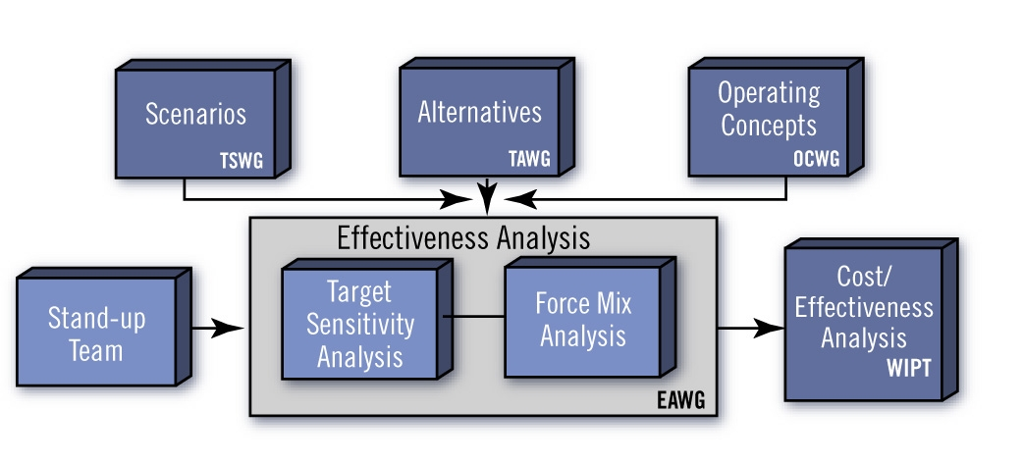
Figure 7-1. Effectiveness Analysis Process

As the EAWG determines the relative worth of each of the individual concepts, they may find that no single PGS concept is suitable for all potential PGS targets. In this instance, the EAWG combines or mixes the concepts into a single alternatives. This force mix analysis is dependent upon linkages of these targets to timelines. The scenario and the targets set the stage for the volume of fire and timing requirements for the force mix analysis. For example, a scenario with only four expected targets distributed over a one-year time period would demand a much smaller force mix than a scenario with multiple targets being engaged near simultaneously in several theaters. Linkages to MCO deployed forces are also a driving factor in forward presence in each theater for COA selection. Wargames may also be used to help define optimization parameters for subsequent modeling. This force mix analysis trades PGS concepts against one another, however it does not trade PGS alternatives against other systems. For example, the EAWG does not study the possibility of replacing a carrier battle group by a PGS alternative (unless additional carrier battle groups are a part of a PGS alternative).

For this force mix analysis, the EAWG may use a linear programming tool (such as New Design Paradigm [NDP]) to examine important weapon characteristics. The EAWG couples its use of a linear programming tool with a design of experiments to optimize the force mix parameters and weights. The EAWG is still evaluating the best approach for this portion of the Effectiveness Analysis. Key to this entire analysis is the boundary conditions set on the vignette timing and targeting requirements. The EAWG inserts additional USSTRATCOM or Joint Staff Global Strike vignettes, as appropriate.

The effectiveness analysis and this plan are an iterative process with updates coordinated between the EAWG, OCWG, TAWG and CAWG. For example, the TAWG and CAWG may determine the Air Force might buy 27 of “System A”. However, through its force mix analysis, the EAWG may determine that 35 of “System A” would provide additional/better utility. The TAWG and CAWG would then need to determine if it is feasible to purchase 35 systems.

Detailed Effectiveness Analytical Plan

The EAWG develops a detailed analysis plan to address all aspects of Section 7.2. The analysis plan provides the next level of detail for the analysis process and is drafted when the alternatives are identified by the TAWG and the initial selection of models has been identified. The model selection process is an internal EAWG effort that starts during the concept collection phase but is not complete until the alternatives are finalized. The target audience for this analysis plan is the modelers and analysts in the EAWG responsible for generating the MOEs for each alternative. The analytical plan is the key document for the accreditation process (Section 7.5) of the models used in the analysis. It provides the model linkages for inputs and outputs and the analysis process for MOE comparisons of alternatives. The analysis plan is an EAWG deliverable for the AoA and the key document for development of the effectiveness section of the final report. The analysis plan is tailored to the complexity of the analysis process and documents the analysis process and any analytical assumptions identified throughout the process. The EAWG, with WIPT oversight, refines the analysis plan. The content of this document includes, but is not limited to, the following for each of the capabilities:

- Capabilities analysis
- Organization responsible
- Analysis methodology
- Description of model
- Purpose of model runs
- Assumptions
- Limitations
- Input parameters
- Output measures
- MOEs generated
- Linkage between models for MOEs
- Model run matrix
- Example output analysis products/charts
- Security classification measures

The EAWG will provide a detailed analysis plan once the PGS concepts are received. The EAWG will provide an interim status update and detailed analysis plan to the WIPT for approval and distribution to appropriate organizations.

Models and Data

Model selection is driven by concepts submitted to the EAWG. This includes a broad canvassing of models available to the analytic community, including those proposed by each participating service. The EAWG forms a Model Selection Team (MST) that is a subset of the EAWG membership. The EAWG intends for an Air Force Studies and Analysis (AFSAA) M&S-qualified analyst to head the M&S selection. The MST provides initial model selection criteria and recommend models for use in the AoA. The MST members are placed at the disposal of the AFSAA Chief of M&S Selection. The EAWG reviews and approves the model selections prior to submission to the WIPT.

Members of the MST then work with the Accreditation Support Working Group (ASWG) (see Section 7.5) to assist in accreditation of the key campaign (if applicable) and mission level models used. The MST reviews key system performance parameters and accomplishes or directs a critical peer review to ensure consistency and subject matter expert review to ensure accuracy. The MST documents their recommended models and provides the recommendation to the ASWG for construction of the Accreditation Support Package as described in Section 7.5. The Accreditation Support Package is an appendix to the AoA final report.

The EAWG determines the effectiveness of each alternative using the M&S hierarchy as shown in Figure 7-2. Engineering modeling is a joint effort of the TAWG and EAWG.

The models for the EA are dependent on the concepts brought forward to the PGS AoA. Currently, candidate models to conduct the initial analysis and concept screening include, but are not limited to, the System Effectiveness Analysis Simulation (SEAS) and Super Suppression of Enemy Air Defenses (SuperSEAD).

As Navy and Army alternatives are identified, models acceptable to those communities might be added to this list. Once the alternatives are refined and developed, more specific mission level modeling is conducted to compare the alternatives in operational scenarios. In addition, soft analysis may be conducted by subject matter experts as appropriate.

The EAWG uses these models to assess the PGS missions associated with the scenarios recommended by the TSWG. For example, SEAS can assess MOE 5 (Number of high-payoff targets neutralized (by target type, total number, by time) with MOE data captured in the killer-victim scoreboard output file and its measures of utility file.

RESOLUTION FUNCTIONS SUPPORTED MODELS/SIMULATIONS FORCE OR SYSTEM LEVEL

Theater/
Campaign

Mission/Battle
(Groups of Systems – force Packages)

(Many-on-Many)
Engagement
(One-on-One)

Engineering
(System/Subsystem/Component
Operational Req’ts
Development

Effectiveness Analysis

Tactics Development

Mission Planning & Rehearsal

Joint/Combined Forces
(Air Wings;
Battle Groups; Corps)

Air Wing

Aircraft System

Air Vehicle

Fire Control

Radar

Test & Evaluation

Increasing
Aggregation

Comparative
Results

Actual
Performance

Increasing
Resolution

Design Manufacturing
Cost
Support Dev
Tech Reqt’s Dev

Figure 7-2. Modeling and Simulation Hierarchy

Potential engineering-level models for weaponeering and targeteering purposes include:

- JMEM: The Joint Munitions Effectiveness Manuals can provide highest level of weaponeering fidelity (lowest level of the M&S pyramid). JMEM provides damage/kill probabilities for specific weapons and targets, physical and functional characteristics of munitions and weapon systems, target vulnerability, obscuration impact on weapon effectiveness, and analytical techniques and procedures for assessing munitions effectiveness.
- IMEA: The Integrated Munitions Effectiveness Analysis receives JMEM data to plan engagement/mission-level target attacks and assess expected damage.
- QTAR: The Query Tool for AoA Results consolidates the many dimensions of weaponeering (munition type, probability of kill, target type, delivery mode, warhead composition, etc.) with IMEA damage assessments in an integrated environment for tradeoff decisions.
- NDP: New Design Paradigm is a University of Pennsylvania, simulation-based environment for design optimization. It allows multi-dimensional trade space visualization to rapidly evaluate thousands of design feasibility options. It enables analysts to reduce cost early in design processes.

Accreditation of Models and Data

The AFSPC/DR OAS field office leads the Accreditation Support Working Group. The ASWG is a review group totally independent of the leadership of the PGS AoA, and therefore able to render accreditation recommendations without conflict of interest. The EAWG’s Model Support Team as well as members of the other PGS AoA working groups supports the ASWG chair. The ASWG presents the accreditation results to the EAWG chair and the AoA Study Director for comments, and then to the HQ AFSPC/DR for approval to use the selected models within the AoA.

The ASWG will accredit all engagement, mission, and campaign level models used for effectiveness analysis. Engineering and cost models used within the AoA are not accredited, however, the EAWG reviews the cost and engineering models for appropriate use. The ASWG also examines data sources for these models. Although models used during scoping analyses do not directly evaluate any concept that may be recommended at the end of the AoA, the output may be used to eliminate concepts prior to development of the alternatives. The EAWG anticipates models being used for alternative down-selection would likely fall into the engineering/mission level. Some of the models may be used before the accreditation is completed, however, if any model used is not accredited at a later date, then those concepts that were evaluated are re-examined with an accredited model.

The ASWG follows a process consistent with the OAS AoA Handbook and AFI 16-1001. The following are the minimum requirements (per AFI 16-1001) which the ASWG assesses for each model:

- Review the model and simulation’s (M&S) development history, summarize past application(s), and define its application domain based upon a description of capabilities by the model and simulation developer
- Review the adequacy of the model's configuration control and complete an acceptable face validation examination, if appropriate
- Develop categories of key capabilities and criteria for them which the model must meet
- Compare the model’s capabilities and credibility, based on V&V (verification and validation) status, to the capability criteria. Assess risk of accepting the capabilities if they do not meet the criteria thresholds, or have not had sufficient V&V
- Ensure that model documentation exists and is current/sufficient for the intended use. This documentation normally includes the M&S conceptual model, user's guide, and programmer's and analyst's manual(s)
- Ensure that data sources have been identified and both producer and user data VV&C (verification, validation and certification) activities were accomplished

Other Supporting Analysis

The EAWG attempts to leverage all previous analysis done regarding PGS-type systems. Additionally, the EAWG leverages material from ACC’s Next-Generation Long Range Strike activities and the Land Based Strategic Deterrent AoA, where appropriate.

The EAWG, TAWG, and CAWG are each responsible for risk analysis in their own areas of expertise.

Deliverables

The EAWG prepares a summary documentation of all the analyses in a manner meaningful to the decision maker. The analysis results will provide insights into the relative effectiveness of the individual alternatives, and comparisons of alternatives. If two or more alternatives emerge having comparable effectiveness, their strengths and weaknesses relative to each other are further explained in the analysis. The WIPT approves recommended excursions. Deliverables include:

- Study Plan inputs
- Analysis Plan
- Input data to the model accreditation team
- Scoping inputs for the TAWG
- Effectiveness results for the Cost Effectiveness Analysis
- Progress Report inputs and briefings
- Final Results Briefing inputs
- Final Report inputs.

Cost Analysis

Introduction

The Cost Analysis WG is responsible for performing a complete and sufficient PGS AoA cost analysis. The primary objective of this analysis is to develop a life cycle cost (LCC) estimate for each alternative and a rough order of magnitude (ROM) estimate for each excursion addressed in the effectiveness portion of this study. In addition, the CAWG provides ROM estimates for use in the concept screening process. The estimates includes research and development (R&D), investment, operations and support (O&S), and disposal costs. Within the O&S phase, the estimates includes manpower costs. The cost analysis working group (CAWG) also develops comparable WBS, allowing future studies the ability to use comparable systems. The following sections describe specific cost ground rules and assumptions, cost methodology, models and data, LCC estimates, and sensitivity/risk analysis.

Cost Ground Rules & Assumptions

The overarching assumptions for the study are detailed in Section 1.3.4. The cost-specific ground rules and assumptions are detailed in this section.

Ground Rules

- The CAWG conducts and prepares the cost analysis in accordance with Department of Defense Directives.
- All costs are presented in fiscal year (FY) 06 base year dollars (BY$) and also in then year dollars (TY$) for each applicable appropriation. Presentation of cost data in BY$ or TY$ utilizes the most current Office of the Secretary of Defense inflation indices.
- Costs are estimated to the 50% and 80% confidence levels for both base and then year dollars.
- Sunk costs, although identified in the report, are not part of the LCC estimates of the alternatives.
- LCC estimates includes the cost to develop, field, operate, maintain and dispose of a system.
- An alternative may be composed of multiple concepts, consisting of space, air, ground, and sea system platforms. The WBS is sufficiently inclusive to make “apples to apples” LCC comparisons across all life-cycle phases as required.
- AFSPC anticipates PGS is an Acquisition Category (ACAT) I program, and, therefore, requires OSD and Air Force Cost Analysis Agency (AFCAA) involvement throughout the cost analysis process. (AFCAA is currently a member of the CAWG team and has agreed to perform a sufficiency review.)
- If program offices are currently established for any of the alternatives, the CAWG requests the program office provide program office estimates (POE) or other analyses as appropriate to support the AoA. The CAWG uses existing cost analyses to the maximum extent possible.
- Cost as an independent variable (CAIV) is considered throughout the cost analysis process. As part of the CAIV analysis, affordability constraints are taken into account as they relate to the available funding and/or the probability of obtaining funds for the program.

Assumptions

- Systems’ or a portion of a systems’ funding over the life cycle that are included in an approved budget prior to FY08, are treated as “sunk” costs or government furnished equipment in the LCC estimates.
- The AoA includes costs for FY08 and beyond.
- System operational lifetime is full operational capability (FOC) plus 10 years for cost.
- LCC estimates are based on peacetime operations using a force structure that meets expected readiness needs and peacetime/wartime tasking requirement.
- If enabling and supporting capabilities are needed for an alternative, and are unlikely to be utilized for other purposes, then that system’s entire LCC must be included in the alternative’s LCC estimates However, if the system is expected to have many applications outside an alternative, then the estimates only include the incremental cost as it applies to the alternative.
- Attrition rates for aircraft are not included in the estimates.
- IOC is 2020; the full operational capability (FOC) for the PGS AoA is to be determined once the concepts within the alternatives are identified. Since an alternative may consist of multiple concepts, multiple FOCs may be defined within each alternative
- System operational lifetime for cost is FOC plus 10 years.

Cost Methodology

The CAWG, in accordance with the policies and common practices used by the Air Force cost analysis community, uses the best-suited cost methodologies to estimate the selected alternatives and excursions. These policies and practices include identifying key constraints and assumptions in preparing a common WBS, employing recognized and acceptable cost models/techniques, defining the scope of the LCC estimates, describing the basis and/or rationale of LCC estimates, accounting for cost sensitivity, and risk. The CAWG provides a cost template to the TAWG for the cost inputs and variables needed in the TDD. Although the alternatives for case 1 and case may differ, the cost methodology is the same. As applicable, the CAWG will leverage the case 1 results for the case 2 costing effort.

Planning

As an initial step, the assembled CAWG (a tentative list of members is shown in Table 8-1) develops a team charter. In addition to outlining the organizational roles and responsibilities, the charter creates a “cost responsibility matrix” as shown in Table 8-1. The CAWG uses the matrix to assign and track cost analysis taskings. Any organizations listed in the CAWG’s charter (displayed in first row in the responsibility matrix) are considered to be primary stakeholders within the cost portion of the analysis. As such, these organizations have varying responsibilities (e.g. “P”, “S”, or “R”), with respect to their applicable areas of interest and expertise. "P" indicates Primary Responsibility, "S" indicates Supporting Organization, and "R" indicates Reviewer.
Table 8-1. Cost Responsibility Matrix

Task | AoA  CAWG | AFSPC  FMª | OAS^{b} | AFCAA | SPOs^{c} | Ops  Centers | Nat’l  Community | Sister Svs | Due  Date
Lead AoA CAWG |  | P | S | S |  |  |  |  | TBD
Develop ground rules and assumptions | P | R | S | S | S | S | S | R | TBD
Develop WBS | P | R |  | R | S | S | S | S | TBD
Develop/review cost methodology | P | R | S | S | S | S | S | S | TBD
Identify cost models and data sources | P | R | S | S | S | S | R | S | TBD
Write cost section of study plan | P | R | S |  |  |  |  |  | TBD
Provide data requirements to other working groups | P |  |  |  | S | S | S | S | TBD
Develop, amend, and document LCC | P | R |  |  | S | S | S | S | TBD
Identify cost drivers | P | R |  |  | S | S | S | S | TBD
Identify phase-in and steady state periods and quantities | P | R |  |  | S | S | S | S | TBD
Assess AoA milestone schedules | P |  | S | S | S | S | S | S | TBD
Perform cost and schedule risk analysis | P |  |  | R | S | S | S | S | TBD
Perform sensitivity analysis | P |  |  | R | S | S | S | S | TBD
Time phase estimates/convert to TY$ | P |  |  |  | S | S | S | S | TBD
Analyze cost results | P | R | R |  | S | S | S | S | TBD
Write cost section of AoA report | P | S | R |  |  |  |  | R | TBD
Prepare cost briefings for reviews | P | S | R |  |  |  |  | R | TBD
Provide guidance/conduct sufficiency reviews |  |  | S | P  If  ACAT I |  |  |  |  | TBD

a Operating Command/Plans and Financial Management Directorates P – Primary Responsibility
b Office of Aerospace Studies S – Supporting Organization
c System Program Office R – Reviewer

Cost Analysis Approach

The AoA cost analysis centers around seven key tasks, yielding a complete and successful cost analysis. These tasks, and the order in which they are performed, are outlined in Figure 8-1 below.

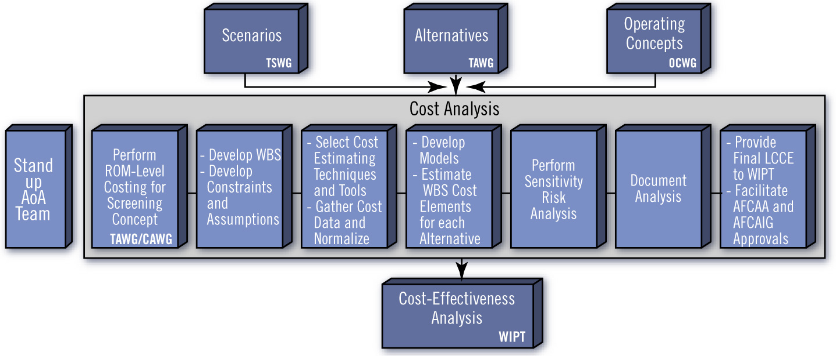

Figure 8-1. CAWG Activities Flow

Accurate LCC estimates begin with a clear understanding of the concepts/alternatives. This understanding is gained by the CAWG’s active participation with other WG’s in the development of the concepts/alternatives’ goals, objectives, schedule, system quantities, and documentation. The CAWG’s early-on participation is vital, and helps ensure concepts/alternatives characteristics are defined in “costable” terms. Once the RFI is completed, the CAWG performs a ROM-level costing effort to assist in the screening performed by the TAWG. These inputs are used to develop a preliminary WBS. As the concepts/alternatives become further defined, changes to the WBS are made reflecting these new developments/assumptions. This task focuses on the creation of a more comprehensive WBS and identify cost elements unique to the PGS alternatives. As a starting point, the CAWG utilizes WBSs identified in Mil Handbook 881 for air, space and surface components. A generic top-level WBS for unclassified concepts/alternatives is shown Table 8-2. The CAWG tailors this WBS for each alternative as required.

Table 8-2. Development/Production WBS

WBS Number | Notional WBS Element
1.0 | Space System
1.1 | Launch Vehicle
1.2 | Orbital Transfer Vehicle
1.3 | Space Vehicle
1.4 | Ground C3 and Mission Equipment
1.5 | Flight Support Operations and Services
1.5.1 | Mate/Checkout/Launch
1.5.2 | Mission Control
1.5.3 | Tracking and C3
1.5.4 | Recovery Operations and Services
1.5.5 | Launch Site Maintenance/Refurbishment
1.6 | System Test and Evaluation
1.7 | Training
1.8 | Common Support Equipment
1.9 | Initial Spares and Repair Parts
1.10 | Disposal

While the goal is to show at least three levels of detail in the WBS, determination of the appropriate WBS level is based on the projected level of risk, cost of the system(s), and data availability. Although the CAWG focuses on using the standard WBS, it may be necessary to use a family of systems (FoS) WBS that identifies all applicable cost elements for space, air, and surface. Merging sets of different cost elements (e.g. space, air, and surface) into an overarching WBS ensures all aggregated cost is included in the LCC estimate.

Since many parameters are originally defined by separate WGs, they are often inconsistent with other aspects of the acquisition program. The WBS helps ensure all issues are addressed and serves as a starting point from which the CAWG can fully discuss each cost element with the appropriate technical/engineering and program execution representatives. The CAWG also ensures the WBS for the alternatives are comparable and meaningful. This includes identification of a complete and common set of cost elements.

In addition to developing the WBS, the CAWG identifies and coordinates cost constraints and assumptions. As concepts are further developed and additional information is received, the CAWG further defines constraints and assumptions for this analysis to ensure consistency.

Cost Models and Data Collection

The CAWG attempts to use DoD approved cost models and techniques. When an “off the shelf” model isn’t available to estimate specific cost elements, the CAWG utilizes other cost estimating tools and techniques. The cost models are expanded as service-specific models are identified for use in the AoA. The CAWG also leverages existing POEs, historical experience, current contracts, vendor estimates, and engineering assessments.

Cost Models

While the following list may not include all models, it is likely the CAWG will choose to use models off this list to accomplish LCC analyses for this AoA. Table 8-3 lists the cost models and data the CAWG expects to use to accomplish LCC analysis. Section 13 provides a brief description of the models. The list of models chosen will be included in the final report.

Table 8-3. Potential Cost Models/Tools and Data Summary

* Spreadsheet models to be used in concert with risk  analysis models to arrive at risk/sensitivity results |  | Cost Element |  |  |  | Risk Analysis
 |  | R&D | Investment | O&S | Disposal | Risk Analysis
Models & Tools | ACEIT | X | X | X | X | X
Models & Tools | SEER-SEM/SEER-H | X | X |  |  | X
 | PRICE S & H | X | X | X |  | X
 | USCM | X | X
 | COCOMO II | X | X | X |  | X
 | NAFCOM | X | X
 | MACDAR | X | X
 | Custom Cost Spreadsheet | X | X | X | X | X*
Data | Analogous Programs | X | X | X | X | X
Data | Current Contracts | X | X | X |  | X
Data | Engineering Estimates | X | X | X |  | X
Data | Vendor Estimates | X | X | X |  | X
Data | Program Office Est. | X | X | X | X | X
Data | Gov't Planning Factors | X | X | X | X | X

The primary determinate for selecting a cost model is data. Throughout this study, the CAWG evaluates AoA cost data and select a model that provides the greatest level of detail based upon data availability. In some cases, the CAWG may develop a system estimate (e.g. flight software) in one model and then migrate to a more detailed cost model as more data becomes available. This migration serves two purposes. The first is a more detailed estimate and the second is a cross-check. When selecting cost models, the CAWG must take into consideration whether or not the cost model is accepted by the DoD. If a cost model is not approved by the DoD, then the CAWG includes extensive documentation and justification as to why a particular cost model was used. The CAWG uses reasonable effort to utilize DoD-approved cost models.

In parallel to selecting specific cost models for the system estimates, the CAWG also selects a cost model for the overall LCC estimate integration. To properly integrate multiple system estimates from different cost models into a LCC estimate, a single cost model is used. ACEIT tends to be the preferred integration cost model and allows the user to input multiple system estimates from different cost models. This flexibility makes it a prime candidate for the cost integration requirement. However, in some situations, it may be necessary to develop a customized cost model. If the CAWG is unable to use ACEIT for integration, a customized cost model is developed. This customized cost model is built in Microsoft Excel. Both ACEIT and Microsoft Excel are DoD-approved tools.

Cost Data Collection

Data identification and collection is an extensive process, therefore, the CAWG starts the collection process early. Several categories of data are required when developing an LCC estimate. The first category is design-related. The system design of each concept must be characterized in quantitative terms. Design parameters may include a system’s weight, power, altitude, software lines of code, and number of antenna modules, which can be used as input variables in a parametric cost estimating models (e.g., SEER, PRICE). Other types of data relate to the implementation and operation of a system during its life cycle. These include, but are not limited to, the number of spacecraft in a constellation, type of orbit, number of ground installations, and other operational considerations.

Data Sources

Once the cost estimating methodology and model(s) are selected, the data requirements become apparent. Sources of data the CAWG pursues include:
- Comparable or Analogous systems’ data (includes existing cost estimating products, data repositories and other historical data) are used when specific system details are not available. The CAWG adjusts (normalizes) this data to reflect the proposed system.
- Engineering estimates are used when the system definition matures and system specific data replaces comparable system data. System engineers are the primary source for specific, reliability and maintainability data.
- Logistics Support Analysis Record (LSAR) provides a single consistent source of logistics data for O&S cost analyses. The program LSAR includes specific data on reliability, maintainability, training, support equipment, provisioning, packaging, and facilities.
- Other existing data sources supplements these sources with information specific to the PGS effort.

The CAWG also makes a formal request to all government organizations responsible for concepts within the alternatives. The request is made to ensure both soundness of methodology application and accuracy of computational results. The CAWG reviews estimates submitted by organizations outside the AoA (to include POE) and modify as required.

The CAWG also surveys C4ISR activities within the DoD and other agencies and identify programs or elements that may incur a cost increase (or decrease) as a result of an alternative being implemented.

An important aspect of gathering sensitive cost data is conveying the AoA’s need for accessing the cost data. The CAWG explains to the data maintainers what specific data items are needed, how the data is used, and how it is protected (classification and proprietary issues). To coordinate the gathering of cost data and system performance data from government sources, all data requests are processed and handled by the designated data custodian. The data custodian submits formal requests to specific organizations and ensures the data obtained is handled with appropriate sensitivity.

Subject Matter Experts

When specific program data is not available, the CAWG identifies and solicits the active participation of SMEs, technical specialists, program analysts, cost analysts, and other key professionals. Since some of the alternatives consist of notional concepts, the CAWG relies on the SME to define a concept in “costable” terms. Once these individuals are assembled, the team focuses on developing a plan of action for producing cost data. At a minimum, this planning assigns tasks, devises a method to track task accomplishment, sets a detailed timeline/schedule for execution of the cost gathering, identifies cost data deliverables, and specifies the resources required for successful delivery. Each member is responsible for ensuring his or her task is complete and on time. Since the development of LCC estimate is largely dependent on data gathering, the CAWG lead must ensure strict adherence to the delivery schedule.

Life Cycle Cost Analysis

Various methodologies and numerous estimating models are available to the CAWG for performing the cost analysis. The level of technical definition available, the alternative's relationship to current technology, and the availability of actual or analogous cost information defines the CAWG’s selection of the cost methodology and models used in costing alternatives.

The CAWG considers a variety of formal and informal methods for use in developing the LCC estimates for each alternative. The formal approaches are parametric, analogy, and engineering build-up (bottoms-up); informal approaches includes expert opinion or engineering judgment. Informal approaches are used when formal approaches are not practical.

The methodology used depends on the level of concept/alternative definition, amount of detail required, availability of data, and time constraints. The Air Force recommends using parametric estimating techniques on AoAs. However, the CAWG employs the most appropriate method for each element within a particular system. The most appropriate method is determined based upon the best possible use of recent and applicable historical system data and the accuracy of the results. As is the case with many analyses, the CAWG utilizes a combination of these estimating techniques to arrive at the most accurate result.

Once the methodology is determined, the CAWG begins the process of costing the alternative. This process is the primary analytical task wherein collected data is entered into the chosen techniques/models for each cost element to derive a comprehensive LCC estimate. As previously noted, the CAWG utilizes a mixture of techniques/models best suited given the available data, time constraints, and nature of the alternatives.

Important to this step, and applicable throughout this analysis, is the integration of Cost As an Independent Variable (CAIV) analysis. CAIV is essentially a tradeoff analysis between cost and the other primary cost drivers. To apply CAIV, the CAWG addresses total ownership costs, schedules, and performance. Even though the AoA should ideally be unconstrained by cost, there may be budgetary and/or political constraints that necessitate the need to optimize effectiveness given a specific cost target.

Research and Development Cost

The cost of research and development (R&D) (Concept Exploration, Program Development and Risk Reduction, and Engineering and Manufacturing Development) is included. Non-recurring and recurring R&D costs for prototypes, engineering development equipment, and/or test hardware (and major components thereof) are shown separately. Contractor system test and evaluation, and government support to the test program is fully identified and estimated. The cost of all related R&D, such as redesign and test efforts necessary to install hardware or modify software into existing equipment are included.

Investment Cost

Investment costs include the total production cost for the Prime Mission Product (PMP), to include both hardware and software, and any related PMP support. PMP support may include command and launch equipment, support equipment, training, data, initial spares, war reserve spares, pre-planned product improvement program items, and military construction (MILCON). MILCON cost includes acquiring, constructing, and/or modifying a facility as necessary to accommodate each of the concepts. The cost of all related procurement, such as modifications to existing equipment, are also included. Non-recurring and recurring costs for the production of PMP and major support equipment are shown separately.

Operations and Support Costs

Operations and support (O&S) costs are program costs necessary to operate, maintain, and support a system’s capability. These costs include all direct and indirect elements of a defense program. O&S elements are those outlined in the WBS contained in the Office of the Secretary of Defense Cost Analysis Improvement Group Handbook, May 2002. http://www.dtic.mil/pae/. The O&S Cost element structure is divided into six major categories. The basic scope and intent of the six major categories are retained, even if changes are agreed to for lower level entries. The categories are:

- Unit Personnel -- Cost of operators, maintainers, and other support personnel assigned to operating units. Includes military, civilian, and contractor personnel.
- Unit Operations -- Cost of unit operating material (e.g., fuel and training material), unit support services, and unit travel. Excludes all maintenance and repair material.
- Maintenance -- Cost of all maintenance other than maintenance personnel assigned to operating units. Includes contractor maintenance.
- Sustaining Support -- Cost of support activities other than maintenance that are attributed to a system and are provided by organizations other than operating units.
- Continuing System Improvements -- Cost of hardware and software modifications to keep the system operating and operationally current.
- Indirect Support -- Cost of support activities that provide general services that are directly attributed to a system. Indirect Support is generally provided by centrally managed activities that support a wide range of activities.

Disposal Cost

Disposal costs are those costs incurred to dispose of a system at the end of its useful life. It may include the costs of demilitarization, detoxification, redistribution, transfer, donation, sales, salvage, or destruction. It may also reflect the costs of hazardous waste disposition (including long-term storage), and/or environmental clean up. It is important to note, that environmental costs may incur at any acquisition phase, and are included in the phase where the costs are incurred (e.g. R&D, investment, O&S, or disposal). Environmental regulations, treaties, and other overarching legalities are addressed and taken into account when determining disposal costs.

Total LCC

LCC estimates are summarized by alternative, separating cost by appropriation in BY06$ as shown in Table 8-2. Additionally, the LCC for each alternative is shown in BY06$ and TY$ by FY as shown in Table 8-3. The CAWG uses the most current OSD inflation indices to establish constant or TY dollars and for adjustments to historical cost data. In the cost documentation each alternative’s cost estimate is broken down to the lowest WBS level possible in both BY$ and TY$.

Table 8-4. Appropriation Level Cost Reporting Format (BY$)

Weapon System | Cost Element (BY06$) |  |  |  |  | Manpower
Weapon System | R&D | Investment |  | O&S | Total LCC
Weapon System | R&D | Production | MILCON | O&S | Total LCC
Baseline
Alternative 1
Alternative 2
Alternative 3
Alternative 4
Alternative 5
Alternative 6
Alternative 7
Alternative 8
Alternative 9

Table 8-5. Appropriation Level Cost Reporting Format (BY06$ and TY$)

Alternative X Costs (BY06$ and TY$)
Cost Element |  | Fiscal Year |  |  |  |  |  |  | Total
 |  | 06 | 07 | 08 | 09 | 10 | 11 | N | Total
R&D
Invest-ment | Production
Invest-ment | MILCON
O&S
Manpower
Total

In addition to displaying the LCC estimate results, cost documentation is also developed. Cost documentation is a detailed record of the methodology, data, environment, and events resulting in the development or update of a LCC estimate. The CAWG documents the results of the cost analysis in such a way that outside organizations/analysts can understand, verify, and replicate. The AoA Cost analysis documentation is a “living document”; and, therefore, continues to be revised as the AoA progresses. Summary level results from the AoA cost analysis are also presented in the final AoA report.

The CAWG accomplishes complete documentation for each alternative through all phases of the AoA. Documentation includes identification and clarification of the methodology, computations, and summarization of the LCC estimates by alternative. AFI 65-508 is used as a guide for preparing the appropriate level and amount of detail in the documentation. Other AoA cost documentation references include: DoDD 5000.4, DoD 5000.4-M, DoD 5000.4-M/AF Sup 1, AFI 65-503, and the OAS AoA Handbook.

Specific documentation elements and guidance the CAWG utilizes include:

- When a Cost Estimating Relationship (CER) is used, it is presented and its source fully cited, or the model and the set of data with which it was calibrated are cited.
- Where subjective judgments are used to adjust estimates made via analogy with other systems or components of systems, the professions of those making the judgments are identified (e.g., cost analysts, engineers, etc.) and full citations for the sources(s) are provided.
- Consideration is given to environmental costs, which historically have rarely been addressed in LCC estimates. Examples of such costs include pollution prevention, hazardous waste management, demilitarization and disposal of equipment, and cleanup of real estate. These costs can arise during any phase of a program, but are more commonly found in the disposal phase.
- Actual historical costs from past or present contracts or analogous programs when used in the estimate.
- Areas of uncertainty, such as pending negotiations, concurrency, schedule risk, performance requirements that are not set, appropriateness of analogies, level of knowledge about support concepts, critical assumptions, etc., is included.
- When an estimate changes, specific reasons for the change is documented.
- The CAWG ensures necessary inputs are incorporated into the TDD. The CAWG performs a final review/approval of these inputs ensuring they are consistent with the PGS AoA LCC estimates.

Cost Sensitivity and Risk Analysis

Sensitivity analysis, also known as “What-if” analysis, identifies how costs of different alternatives change, and even whether the “optimal alternative” changes, as the input parameters change. One of the goals of sensitivity analysis is to determine which parameters have the greatest impact on the results. As the parameters are adjusted across a given range, how that adjustment affects the results (and optimal alternative) is recorded. The final report addresses the impact of the most influential parameters and how costs and alternatives are influenced by the sensitivity analysis.

The purpose of conducting risk analysis is to identify and analyze the technological, cost, schedule, and program risks associated with an alternative. This is accomplished by incorporating insight/data from current or legacy analogous programs as well as collecting insight/data from new or evolving systems or capabilities. For the PGS AoA, the CAWG interfaces primarily with the TAWG, OCWG, and AoA subject matter experts (SME) to capture the associated risks for the alternatives.

In order to conduct a risk analysis, the CAWG groups performance/technical, cost, schedule, and program risk/uncertainty together under one comprehensive cost risk measurement. Thus, comprehensive cost risk is a measurement of the potential inability to achieve the overall program objectives within a defined cost, schedule, technical or program constraint. As such, composite cost risk measurements have two basic dimensions: (1) the probability/likelihood of failing to achieve a particular outcome and (2) the consequences/impacts of failing to achieve that outcome. The assessed values for these two risk dimensions are essential in determining the specific range of (minimum and maximum) risk cost multipliers that are applied to an alternative’s Point Estimate.

Sufficiency Review

The AFCAA has agreed to provide general support to the CAWG for the PGS AoA. In addition, AFCAA has agreed to perform an independent sufficiency review of the LCCEs presented within the PGS AoA. AFCAA may recommend a formal OSD/Cost Analysis Improvements Group (OSD/CAIG) review of the PGS AoA be performed as well.

When performing any AoA sufficiency review the AFCAA assesses the reasonableness, application and completeness of Work Breakdown Structure (WBS) cost estimating methodologies and budget profile.

Deliverables

- Study Plan input
- ROM estimate for each concept which survives the first round of screening (see Section 4.2.1)
- A WBS for each alternative
- LCCEs for each alternative
- ROM for excursions/CAIV analysis as necessary
- Sufficiency Review by AFSPC/FM, AFCAA, and OSD CAIG
- Progress Report inputs
- Final Results Briefing inputs
- Final Report Inputs.

cost-effectiveness

Introduction

The CAWG and EAWGs perform cost-effectiveness tradeoffs and supporting analyses to determine cost-effective alternatives. These two WGs cooperate on the analytical work, with oversight provided by the WIPT.

Methodology and Presentation

Cost-effectiveness comparisons simultaneously consider alternatives' cost and effectiveness. As consumers, we are all familiar with the concept of cost-effectiveness. Whether buying laundry detergent, a new car, or a home, we collect data on cost and make assessments on how well the alternatives meet our needs (how "effective" they are). With data in hand, we make our comparisons and select a winner. In an AoA the process is essentially the same, although usually more formal.

While this kind of cost-effectiveness "analysis" is quite sensible it has difficulty in addressing the need to determine if additional effectiveness is worth additional cost and the need to assess the relative values ("weights") of different measures of effectiveness. Figure 9-1 below illustrates the dilemma of answering the question, “Is the increase in effectiveness worth the increase in cost?”

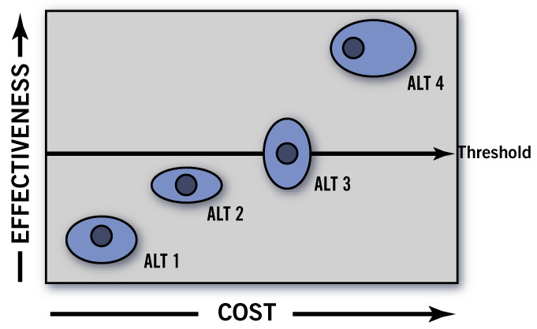
Figure 9-1. Cost-effectiveness Dilemma

From Figure 9-1 we could safely conclude that we would not select alternatives 1 or 2, but the issue is not clear for alternatives 3 and 4. Alternative 3 or alternative 4 are chosen if the increase in effectiveness is judged to be worth the cost. The decision may be somewhat easier if there is a minimum acceptable effectiveness threshold; this would allow the use of a number of the MOEs that are considered critical to accomplishing the mission tasks. With these MOEs, you may be able to consider the alternatives that meet or exceed all of the critical MOEs as the final step leading to selecting the preferred alternative. However, the threshold may be exceeded by more than one alternative as illustrated, and having a threshold does not eliminate the option of "buying nothing" if all alternatives meeting the threshold are deemed too costly.

Figure 9-1 is one example of how the results may be displayed. A multi-dimension interactive visualization tool, such as NDP used in the EAWG sensitivity analysis, are used with cost added as a factor. Care is taken to ensure that any weights given to effectiveness measures for simplification of presentation are clearly defined and visible in the analysis. It is expected that for all the senior review group (SRG) sessions output from this tool are used and available for SRG adjustments. These adjustments and the effect on relative alternative ranking are available for “real time” sensitivity analysis. The WIPT is the approving authority on validated adjustments to these parameters for insertion into the final report. The WIPT, in the cost-effectiveness analysis determines the most conclusive approach and graphics for communicating the results.

Risk Evaluation

As illustrated in Figure 9-1, the cost of an alternative is not an exact figure but rather a range (as represented by an oval’s horizontal width for a particular alternative). Since most alternatives are notional systems, the CAWG interviews AoA SME, industry, government agencies, etc. to determine how much the system costs. As mentioned above, in Section 8.5.6 Cost Sensitivity and Risk Analysis, the alternatives’ PE is adjusted based upon their associated risk. This adjustment is based upon an alternatives’ performance/technical, cost, schedule, and program risk/uncertainty. To ensure an “apples-to-apples” Cost-Effectiveness Analysis, all PEs are adjusted to the same confidence level. To adjust a PE to a specific confidence level, the CAWG performs a risk analysis to determine the various parameters within a Monte Carlo or Latin Hyper Cube simulation. The result of the simulation provide the Cost-Effectiveness WG with comparable LCC estimates for each of the alternatives.

Decision Criteria

Criteria for determining the best PGS force mix is based primarily on cost-effectiveness considerations, with regard to performance in the scenarios considered. LCC of the alternative force mix structures are considered. The MOEs are evaluated for each scenario. From these results, a small set of MOEs are developed for cost-effectiveness comparisons. These MOEs most likely are a subset of the MOEs defined in Measures of Effectiveness (Section 6.2.3).

Deliverables

- Final Results Briefing inputs
- Final Report inputs.

report format

The AoA team submits the report in the following format

EXECUTIVE SUMMARY

Table of Contents
Figures
Tables

- INTRODUCTION
  - Background
  - Purpose
  - Scope
  - ICD Requirements
  - Study Organization
  - Report Content

- SCENARIOS & THREATS
  - Scenarios Descriptions
  - Threats Descriptions
  - Environment

- ALTERNATIVES
  - Alternatives Descriptions
  - Nonviable Alternatives Descriptions

- OPERATIONS CONCEPT
  - OV
  - Tactical Operating Concepts
  - Operating Concepts

- MEASURES OF EFFECTIVENESS
  - Capabilities
  - Measures of Effectiveness (MOE)
  - Measures of Performance (MOP)

- EFFECTIVENESS ANALYSIS RESULTS
  - Analysis Methodology
  - Engagement Results
  - Mission Results
  - Other Supporting Analysis

- COST ANALYSIS RESULTS
  - Analysis Methodology
  - Life Cycle Cost Estimate Results
  - Cost Risk Results

- COST-EFFECTIVENESS RESULTS
  - Methodology
  - Alternative Results

- SUMMARY OF RESULTS
  - Selection of Preferred Alternatives
  - Major Findings
  - Factors Influencing Concept Performance

- CONCLUSIONS

References
Acronyms

Appendix A Organization and Oversight
Appendix B Threats and Scenarios
Appendix C Alternatives
Appendix D Scenario and Threats
Appendix E Effectiveness Analysis
Appendix F Model and Data Accreditation
Appendix G Cost Analysis
Appendix H Major Briefings.

schedule

The projected schedule for PGS AoA activities for case 1 is shown in Figure 11-1. As this Study Plan is a living document, the schedule including case 2 will be developed at a later date. The WIPT maintains the most current version of this schedule throughout the AoA process.

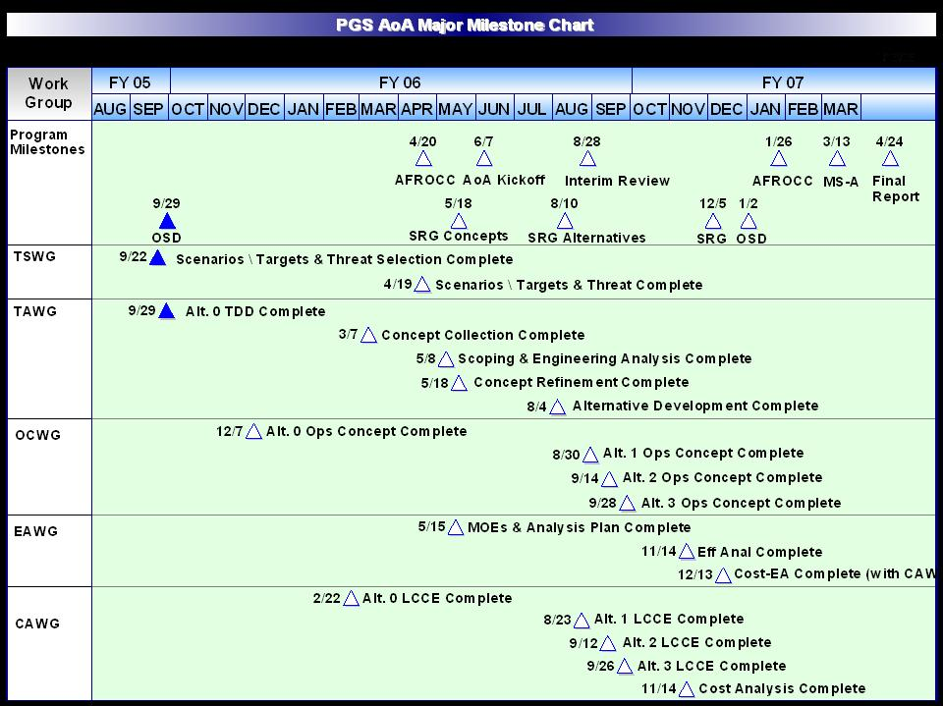

Figure 11-1. PGS AoA Schedule

team members

Team members are listed in the matrix below. This is the current list as of the publication of this Study Plan. The WIPT approves changes throughout the AoA process.

Working Group Membership Matrix

Legend:
S = Stakeholder (not regular attendance at meetings, possible veto authority)
C = Core (regular attendance at meetings)
I = Information provider

 | TAWG | TSWG | OCWG | CAWG | EAWG | WIPT
AAC/YE | I
AAC/XR |  |  |  |  | I
ACC/DO |  |  | C
ACC/DRM | C/S | C
ACC/DRY |  |  |  |  | C
ACC/DRZ | C/S
ACC/INX |  | C
AETC (NSSI?) |  |  | I
AF/BL |  |  | I
AF/XIW |  |  |  |  |  | S
AF/XOIIA-F |  | I/S
AF/XOR |  |  |  |  |  | S
AF/XOS |  |  |  |  |  | S
AFC2ISRC |  |  | C
AFCAA |  |  |  | C
AFMC/FM |  |  |  | I
AFMC/IN |  | C
AFMC/XR |  |  |  | I |  | S
AFOTEC |  |  | I |  | I/S
AFRL | I |  |  | I | C
AFSAA |  |  |  |  | C
AFSOC |  |  | C
AFSPC/DRM |  |  |  |  |  | C
AFSPC/FM | S |  |  | C | S | C
AFSPC/LC | I |  | C | I
AFSPC/XOO |  |  | C
AFSPC/XOT |  |  | C
AFSPC/XPY | C | S | C | S | C | C
AFSPC/INX | I | C | C | I | I | C
AFSPC/XON | C | S | C |  | I/S | C
AIA/IO |  |  | C |  | C
Army  /TRADOC | I |  | C |  | C
Army/CEAC |  |  |  | S | S
Army/G3 |  |  | C |  |  | C
Army/Intel |  | I | I
Army/AMC | I
Army/SMDC | C
ASC/AA | C/S
ASC/ENM |  |  |  |  | C
ASC/XRE |  |  |  | C
Centcom |  |  | C
DARPA | I
DIA |  | C
DTRA | I | C |  |  | C
ESC SPOs | I
ESC/CXP | I
Eucom |  |  | C
IC/CAIG |  |  |  | S | S
JCS/J8 |  |  |  |  |  | S
Jfcom |  |  | C
JWAC |  | I |  |  | I
MDA | I |  | S
NASIC |  | C
National Agencies | I |  |  |  |  | S
National Labs | I |  |  | I | I
NavAir |  |  |  | S
NavAir 4.1 |  |  |  |  | I/S
Navy Analysis |  |  |  |  | C
Navy SSP | C
Navy/N3 |  |  | C
Navy/ONI |  | I | I
Navy/N81 |  |  |  |  | I/S | C
Navy/N71 |  |  |  |  |  | C
USMC/PP&O |  | I |  |  | I | C
Northcom |  |  | C
526 ACQ/GMAG | C | S/I | C | I | C | C
OSD/AT&L |  |  |  |  |  | S
OSD/CAIG |  |  |  | S
OSD/PA&E |  |  |  |  |  | S
Pacom |  |  | C
SAF/USA |  |  |  |  |  | S
SMC/FM |  |  |  | S
SMC/TD | S |  | I |  | S
SMC/IN |  | C
Socom | I |  | C |  | S
Southcom |  |  | C
State Dept |  |  |  |  |  | S
STRATCOM/J87 | C | I | C | S | C | C

.

Cost Model descriptions

The models described below are commonly used for AoA cost analysis. The PGS AoA will determine which models are appropriate once the concepts and alternatives are identified.

Automated Cost Estimating Integrated Tools (ACEIT)

ACEIT is a commercially available cost-estimating product produced by Tecolote Research, Inc., which includes a suite of tools for cost estimation and analysis. It allows an analyst to create tailored cost WBSs, apply learning curves, perform sensitivity and risk analyses, conduct what-if studies, and evaluate cost-proposals. It can generate a wide variety of output tables and cost documentation of backup data as well as assist in the development of a full range of Cost Estimating Relationships (CER).

System Evaluation & Estimation of Resources – Software Estimation and Hardware estimation Model (SEER-SEM) & (SEER-H)

SEER-SEM and SEER-H, developed by Galorath Associates, are parametric cost estimating tools that estimate software or hardware cost and risk. It includes a knowledge base of algorithms to aid the analyst in producing concept level estimates. The model takes into account commercial and military standards, automated tools, software security issues, life cycle maintenance and technology transfers. Parameters describe real world cost drivers such as experience levels and staffing constraints

PRICE Estimating Suite

The PRICE Estimating Suite, developed by Martin-Marietta PRICE Systems and now owned by PRICE Systems L.L.C., is a product used by the international defense community to determine hardware and software development, production, and operating/support costs and schedules. It is the most widely used parametric model in Government and industry and is geared to DoD standards and practices. The PRICE Estimating Suite consists of four modules: PRICE Hardware Development, PRICE Hardware Life Cycle Estimating Model, PRICE Microcircuits & Electronic Module Model, and PRICE Software Development Model. In this AoA, the Cost IPT likely focuses on using the PRICE modules for software and hardware.

Unmanned Spacecraft Cost Model (USCM)

USCM, published by the Air Force, is a parametric cost tool used to estimate spacecraft development and production costs. By using physical descriptions of components, the model's CERs develop component nonrecurring and recurring cost estimates. Other CERs develop support costs such as program management, systems engineering, data, etc. It also estimates subsystems for earth orbiting unmanned spacecraft.

Constructive Cost Model II (COCOMO II)

COCOMO II, authored by Dr. Barry Boehm and managed by the University of Southern California, is a model that allows one to estimate the cost, effort, and schedule when planning a new software development activity. The implemented tool provides a range of its cost, effort, and schedule estimates, from best case to most likely to worst case outcomes. It also allows a planner to easily perform "what if" scenario exploration by quickly demonstrating the effect adjusting requirements, resources, and staffing might have on predicted costs and schedules (e.g., for risk management or job bidding purposes).

NASA/Air Force Cost Model (NAFCOM)

NAFCOM consolidates numerous existing cost models and databases used throughout the National Aeronautics and Space Administration (NASA) and are an increasingly powerful automated parametric cost estimating tool that uses historical space data to predict the development and production costs of new space programs. It uses a parametric relationships to estimate subsystem or component level costs for any aerospace hardware including: Earth orbital spacecraft, manned spacecraft, launch vehicles, upper stages, liquid rocket engines, scientific instruments, or planetary spacecraft.

Multi-Aircraft Cost Data and Retrieval (MACDAR)

AFCAA is the project lead for the MACDAR developed by Tecolote and RAND. It is primarily a database of contractor labor hours and material costs relating to aircraft development and production, which are identifiable at the lowest levels available. This tool serves as a good data source in developing CER for aircraft costing efforts.

Custom Spreadsheet Cost Model

A general-purpose spreadsheet application, such as Microsoft Excel, can be used to create very general cost models. Detailed cost WBSs can be modeled and summarized which uses all of the powerful features of a state-of-the-art spreadsheet package.

acronyms

AFROCC Air Force Requirements for Operational Capabilities Council
AFSPC Air Force Space Command
AoA Analysis of Alternatives
ATR Automatic Target Recognition
BY$ Base Year Dollars
C2 Command and Control
C3 Command, Control, and Communications
C4ISR Command, Control, Communications, Computers and Intelligence, Surveillance, and Reconnaissance
CAIG Cost Analysis Improvement Group
CAIV Cost As an Independent Variable
CAV Common Aero Vehicle
CARD Cost Analysis Requirements Description
CAWG Cost Analysis Working Group
CBD Commerce Business Daily
CEP Circular Error Probable
CINC Commander-in-Chief
COCOM Combatant Commander
CONOPS Concept of Operations
CONUS Continental United States
CPWG Cost and Performance Working Group
D5EN Deny, Delay, Disrupt, Destroy, Exploit, or Neutralize
DIA Defense Intelligence Agency
DoD Department Of Defense
DOF Degrees Of Freedom
DPG Defense Planning Guidance
DPS Defense Planning Scenarios
DTRA Defense Threat Reduction Agency
EAWG Effectiveness Analysis Working Group
ECO Engineering Change Order
EMD Engineering & Manufacturing Development
ESAMS Extended Surface-to-Air Missile Simulation
FO Functional Objective
GI&S Geo-spatial Information and Services
GPS Global Positioning System
HDBTDC Hard and Deeply Buried Target Defeat Capability
HQ Headquarters
ICBM Intercontinental Ballistic Missile
IMU Inertial Measurement Unit
IO Information Operations
IWG Integrating Working Group
WG Integrated Process Team
I&S Interoperability and Standardization
ISR Intelligence, Surveillance, & Reconnaissance
IW Information Warfare
JCIDS Joint Capabilities Integration and Development System
JROC Joint Requirements Oversight
Council
JTA Joint Technical Architecture
LCC Life Cycle Cost
MAA Mission Area Assessment
MaRV Maneuvering Reentry Vehicle
MCAT Missile Capabilities Analysis Tools
MER Manpower Estimate Report
METOC Meteorology and Oceanography
MEVA Modular Effectiveness and Vulnerability Assessment
MILCON Military Construction
MNA Mission Need Analysis
MNS Mission Need Statement
MOE Measure of Effectiveness
MOP Measure of Performance
MSA Mission Solution Analysis
NASIC National Air and Space Intelligence Center
NGA National Geospatial-Intelligence Agency
OCWG Operations Concepts Working Group
OWG Overarching Working Group
O&S Operations and Support
P3I Preplanned Product Improvement
PDRR Program Definition and Risk Reduction
PGS Prompt Global Strike
POL Petroleum, Oil, and Lubricants
QDR Quadrennial Defense Review
R&D Research and Development
RFI Request For Information
RT Relocatable Target
RV Reentry Vehicle
SAM Surface-to-Air Missile
SPG Strategic Planning Guidance
SSC Small Scale Contingency
TAWG Technology & Alternatives Working Group
TBA To Be Added
T&E Test and Evaluation
TSWG Threat and Scenarios Working Group
TTS Template Target Set
TY$ Then Year Dollars
US United States
USAF United States Air Force
WBS Work Breakdown Structure
WG Working Group
WIPT Working-level Integrated Product Team
WMD Weapons of Mass Destruction

REFERENCES

Chairman of the Joint Chiefs of Staff Manual, CJCSM 3170.01, 24 June 2003
Chairman Joint Chief of Staff 3500.04 Universal Joint Task List, 2002
Defense Planning Guidance, 2004-2009
Defense Planning Guidance Long Range Global Precision Engagement Study, Final Report, 1 April 2003, ACC/XPS
Focused Logistics Joint Functional Concept (version 1.0), February 2004
Force Application Joint Functional Concept (version 1.0), February 2004
Global Strike CONOPS, HQ ACC, 24 May 2004
Global Strike Joint Integrating Concept (version 1.0), 10 January 2005
Joint Concept Development and Revision Plan, 30 July 2004
Joint Defense Capabilities Study: Final Report, Joint Defense Capabilities Study Team, December 2003
Major Combat Operations Joint Operating Concept (version 1.0), 20 Jul 2004
Master Capability Library V5.5, HQ USAF/XOR MCL, 15 November 2004
National Defense Strategy, 1 March 2005
National Military Strategy of the United States of America, 2004
National Security Strategy, September 2002
Nuclear Posture Review briefing, January 2002
Prompt Global Strike Mission Needs Statement, 3 May 2003
Quadrennial Defense Review, 30 September 2001
Report of the Defense Science Board Task Force on Future Strategic Strike Forces,
February 2004, Office of the Under Secretary of Defense For Acquisition, Technology, and Logistics, Washington, D.C. 20301-3140
Strategic Deterrence Joint Operating Concept (version 1.0), January 2004
Strategic Planning Guidance, FY 2006-2011
USAF C-CBRNE Master Plan

The Services are only required to show or provide data at that level of breakdown for which they have the data readily available.

